Name: Taina Batista Conde

Project: BeMyGuest

**Table of Contents**

Project Direction Overview **3**

Use Cases and Fields **4**

1. Creating an Account Use Case 4

2. Creating a party Use Case 5

3. Creating a guest Use Case 5

4. Adding gifts Use Case 6

5. Making a Purchase Use Case 7

6. Adding a Companion Use case 8

Structural Database Rules **9**

Conceptual Entity-Relationship Diagram **13**

Full DBMS Physical ERD **14**

PHYSICAL ERD - BEFORE NORMALIZATION 27

PHYSICAL ERD - AFTER NORMALIZATION 28

Stored Procedure Execution and Explanations **30**

Question Identification and Explanations **39**

Question 1 - List of confirmed Guests 39

Question 2 - Birthday Parties for others 39

Question 3 - Show gifts by category of price 39

Query Executions and Explanations **40**

Question 1 - List of confirmed Guests 40

Question 2 - Birthday Parties for others 42

Question 3 - Show number of gifts by price category 44

Index Identification and Creations **45**

History Table Demonstration **50**

Data Visualizations **59**

Data Visualization 1 59

Data Visualization 2 61

Summary and Reflection **62**

**References** **63**

# Project Direction Overview

Planning a party is not an easy task but when the day comes and you are there having fun with your friends and family you realize all the hard work was worth it. I had the chance to experience the stress of planning a big party and the joy of celebrating a unique moment of my life with my friends and family in May 2022, when my husband and I finally got married after many obstacles, including a pandemic. One of the things I had the most difficulty with was the guest list. I made spreadsheets with the guests' names, and the number of people they were supposed to bring to the wedding. Then, after sending out the invitations I had to manage the list to record who confirmed or not. Anyway, that was very time-consuming and an application that manages a guest list could have made it easier for me.

Having shared this story, I face an opportunity to create such an application. That is why for this course I will develop a mobile application that helps people better organize and manage the guest list for the party they want to throw. The app will be called "BeMyGuest". For this course's learning purpose, I will focus on the database component.

As an example of how someone would use the app, suppose Mary wishes to throw a baby shower and wants to use the app to manage her guest list. Mary will create an account and fill out some information about the party such as the occasion (type), date, and location. Then Mary will manually add each guest invited filling out their first name, last name, phone number, and email address. Mary can also select a list of gifts she would like to receive from her guests. After entering all her guests the app will generate an invitation link that she can send out to her guests. When clicking on the link, her guests will see the party information, will be able to confirm their presence, and buy gifts for Mary's baby. Under the confirmation section, as the guest starts typing his/her first name, the app will show guest names that are in the list and that match the letters typed. Then, the guest will select one of the names that match his/her name, enter his/her email address and phone number and select if he/she confirms his/her presence at the event. After submitting, the guest information will be updated on Mary's guest list. The page the guests will access will also have a section where the guest can browse Mary's pre-selected list of gifts. The guest can purchase multiple gifts from the list. The gift will show links to the stores the guest can purchase the gift from. After making a purchase on the store's website, the guest marks that gift as "purchased".

Additionally, if Mary decides she wants to throw a birthday party for her husband as well, she can create another party event and fill out the information and the guest list for this second event. Therefore, when Mary logs in, the first page she will see is a dashboard with the parties she is planning as cards. When she clicks on one of the party cards she will see the party information, the guest list,, and the purchased gifts. The guest list will have information about those who already confirmed their presence.

Regarding the data that needs to be stored in the database, the database will store the party information such as the occasion (type), date, location, and guest list. The database also needs to store the guests' information such as first name, last name, number of people the guest is allowed to bring, and confirmation status. Additionally, the database will need to store the user's information, such as the first name, last name, username, home address, email, and password. The database will store the gifts the user wishes to receive, and record details of the purchases. Additionally, the database needs to store the guest confirmation details and the companions the guest will take to the party. Since the users can create multiple parties with different guests and gift lists, the database needs to associate the parties with the users, the guests and gifts with the parties, and the purchases of gifts, confirmation, and companions with the guests.

There is no intention to charge the users for the service. Thus, those are the details I can think of for this project this week, but I appreciate any suggestions to make this project more robust and increase my learning experience in this course.

# Use Cases and Fields

Here are six use cases and fields for the BeMyGuest app:

## 1. Creating an Account Use Case

1.1 The person visits the app store and installs the BeMyGuest application

1.2 The app asks them to create an account

1.3 The person enters their information and the account is added to the database

1.4 The app takes the new user to a dashboard page with an "add new party" button.

For this Use Case, the database needs to store information about the new account created (steps 1.2 and 1.3). The other steps do not relate directly to the database. The database fields needed for this use case are listed below.

| **Field** | **What it Stores** | **Why it's needed** |
| --- | --- | --- |
| first_name | the account holder's first name | the app will use the first name to address the account holder throughout the application and on emails or other communications |
| last_name | the account holder's last name | the app will use the last name to address the account holder throughout the application and on emails or other communications |
| home_adress | the account holder's home address | The app needs the user's home address to use as a delivery address for the gifts given. |
| email | the account holder's email address | the account holder will use the email to log in and the email will be used when needed to communicate with the account holder outside the app |
| username | a unique name associated with each account | the account holder will use the username or email to log in |
| date_of_birth | the account holder's birthday | The account holder's birthday will be used for marketing purposes. When his/her birthday is approaching the app will send an email to remind him/her to plan a birthday party. |
| password_encrypted | the account password chosen by the account holder, but encrypted for security | the account holder will use the password to log in |

## 2. Creating a party Use Case

2.1 Assuming the account holder is logged in, when the account holder clicks on the "create new party" button, a form with the party information displays on the screen

2.2 The account holder fills out the form with the party information and selects what kind of party this is: wedding, birthday, or baby shower.

2.3 The account holder submits the form and the party information is added to the database

In this use case, only step 2.3 relates directly to the database. The fields needed are listed below:

| **Field** | **What it Stores** | **Why it's needed** |
| --- | --- | --- |
| occasion | the occasion for the party like birthday, baby shower, wedding, college reunion, etc. | The guests need to know the occasion to prepare for the party (buy appropriate gifts, dress accordingly, etc) |
| party_venue | the address where the party will happen | The guests need to know the address of the party to go to the right place. |
| start_date_time | the date and time the party starts | The guests need to know the party's starting time to arrive on time. |
| end_date_time | the date and time the party ends | The guests need to know the party's end time to leave on time. |

## 3. Creating a guest Use Case

3.1 After creating a party, the account holder can add guests to that party by clicking the "add guest button". The account holder adds one guest at a time.

3.2 The account holder fills out the form with the guest information

3.3 The account holder clicks the "save guest" button to add it to the database

In this use case, only step 3.3 relates directly to the database. The fields needed are listed below

| **Field** | **What it Stores** | **Why it's needed** |
| --- | --- | --- |
| first_name | the guest first name | the app will use the first name to address the guest throughout the application and on emails or other communications |
| last_name | the guest last name | the app will use the last name to address the guest throughout the application and on emails or other communications |
| email | the guest email address | The app will use the guest's email to send reminders or updates about the party the guest will attend. |
| number_companions_allowed | the total number of people coming with that guest, excluding the guest | Usually guests are allowed to bring one or more companions to a party. It is important that the guest knows how many people he/she is allowed to bring to the party. |
| confirmation_date | the date when the guest confirmed his presence | The account holder needs to know who is coming to the party to plan accordingly. Some guests may not be able to go. |

## 4. Adding gifts Use Case

4.1 After creating a party, the account holder can create a list of gifts by clicking on the "Registry" button. This button takes the account holder to a page with a list of gifts he/she can choose from.

4.2 The account holder selects the gifts he/she would like to receive for that party by clicking on the "add gift" button, which adds it to the database.

In this use case, step 4.1 creates a Registry instance in the database, and step 4.2 adds a new Gift instance to the database. The fields needed are listed below

| **Field** | **What it Stores** | **Why it's needed** |
| --- | --- | --- |
| item_name | the item the account holder wishes to receive from the guests | The app will use the item name to display on the registry list |
| price | the price of the item | The app will use the price to display on the registry list alongside the item name, so that the guest is aware of the amount he/she has to spend to buy that item. |
| quantity | the quantity of that item the account holder would like to receive | The app will show the guests how many of that item the account holder would like to receive |
| purchased | the quantity already purchased of that item | With the quantity of items desired and how many were already purchased, the app can show the guests and the account holder the gifts still available and the purchased ones. |

## 5. Making a Purchase Use Case

5.1 The guest visits the Registry page

5.2 When the guest finds a gift he/she wants to purchase, there will be links to different stores he can buy the gift from.

5.3 The guest chooses the store he prefers and clicks on the correspondent link. The link takes them to the store url where they can make the purchase.

5.4 After finishing the purchase on the store's website, the guest goes back to the app and confirms that the gift was purchased.

5.5 The guest confirms the purchase and the app records the purchase information in the database as well as the store information.

In this use case, only step 5.5 relates directly to the database. The fields needed are listed below

| **Field** | **What it Stores** | **Why it's needed** |
| --- | --- | --- |
| purchased_item | item purchased | Identifying the purchased items is important to update the gift's purchased field and make it unavailable for additional purchases. |
| purchased_quantity | quantity of the item purchased | Identifying the purchased items is important to update the gift's purchased field and make it unavailable for additional purchases. |
| purchase_date | the date the guest made the purchase | inform the account holder when the purchase was made for tracking purposes |
| guest_id | the guest who made the purchase | Inform the account holder who the gift is from |
| store_name | the name of the store the guest made the purchase | The app records the store, so that the account holder knows where the gift was bought and makes exchanges or returns if needed. |
| store_url | the url of the store where the guest made the purchase | The app records the store, so that the account holder knows where the gift was bought and makes exchanges or returns if needed. |

## 6. Adding a Companion Use case

6.1 The guest can add companions when confirming his/her presence

6.2 The guest enters the companion's information on the confirmation page

6.3 The guest is allowed to enter a predetermined number of companions.

6.4 When the guest submits his confirmation, the companions he/she entered are added to the database.

In this use case, only step 6.4 relates directly to the database. The fields needed are listed below

| **Field** | **What it Stores** | **Why it's needed** |
| --- | --- | --- |
| first_name | the companions first name | The app needs to show a list of names (first +last names) of people that are going to the party, including the companions. This way the guest knows who is going to the party. Also the guest can use this list at the entrance of the party to allow only the people in the list to enter. |
| last_name | the companion's last name | The app needs to show a list of names (first +last names) of people that are going to the party, including the companions. This way the guest knows who is going to the party. Also the guest can use this list at the entrance of the party to allow only the people in the list to enter. |
| guest_id | the id of the guest the companion is associated with | the app needs to associate a companion to a guest |

# Structural Database Rules

Update, if necessary, your list of your structural database rules, along with supporting explanations. Note that at least 10 entities should be identified in your structural database rules, and your specialization-generalization rule should have a supertype and at least two subtypes.

From the use cases, I could identify the following entities: Account (use case 1.3), Party (use case 2.3), Wedding (use case 2.2), Birthday (use case 2.2), BabyShower (use case 2.2), Guest (use case 3.3), Registry (use case 4.1) , Gift (use case 4.2), Purchase (use case 5.5), Store (use case 5.5), and Companion (use case 6.4).

| **N** | **Relationship** | **Explanation** |
| --- | --- | --- |
| 1 | A party is associated with an Account (mandatory, singular). An Account can be associated with many parties (optional, plural) | When the user creates an Account, there are no parties associated with his/her account yet. From the Account's perspective, the word "can" indicates that the relation to the party is optional. Additionally, the user can create multiple parties, so the word "many" is used to show the plural relationship. From the party's perspective, each party does not exist without an Account (the user needs to create a party associated with his/her account). That is why the relationship is mandatory. It is also singular because a party is associated with only one account. |
| 2 | A guest is associated with many parties (mandatory, plural). A party can have many guests (optional, plural) | From the guest's perspective, the user can only create guests if he/she associates them with a party, so the relationship is mandatory. Additionally, a guest can be invited to multiple parties, so the guest to party relationship is plural. From the party's perspective, the user can create a party, but might be still thinking about who he wants to invite. So there might be a party without any guests, at least until the user starts adding guests to this party. Therefore the relationship is optional. It is also plural because the user can invite many guests to a party. |
| 3 | A party can have a Registry (optional, singular). A Registry is associated with a party (mandatory, singular) | From the party's perspective, the user can create a party and decide that he/she doesn't want to receive any gifts from the guests. So, there can be a party with no registry associated with it, which means the relationship is optional. However, if the user creates a registry, he/she can only create one registry for that party. That means that the relationship is singular. From the Registry's perspective, a registry does not exist without a party, and each party has its own particular registry. Therefore, the relationship is mandatory and singular. |
| 4 | A Registry has many gifts (mandatory, plural). A gift is associated with many Registries (mandatory, plural) | To create a registry, the user needs to add at least one gift to it. Otherwise, the registry won't be added to the database. That means that the relationship is mandatory from the Registry's perspective. From the gift's perspective, a gift is only stored in the database when associated with a registry. Each gift can be associated with different registries because many people would like to receive similar or the same gifts. |
| 5 | A Purchase is associated with many Gifts (mandatory, plural). A Gift can be associated with many Purchases (optional, plural) | Purchase to gift is plural because a guest can purchase many gifts in a single purchase. Furthermore, the purchase is only registered in the database if it has a gift, which means purchase to gift is mandatory. On the other hand, a gift can be associated with many purchases since the same gift could be purchased multiple times. It is also possible a gift is not purchased by any of the guests, which means that gift to purchase is optional . Therefore, gift to purchase is optional and plural. |
| 6 | Each Purchase is made by a Guest (mandatory, singular). A Guest can make many Purchases (optional, plural). | Purchase to guest is mandatory because the purchase can only exist if a guest makes that purchase. It is also singular because each purchase is tied to a specific guest. Guest to Purchase is optional because it is possible that a guest won't purchase any gifts. However, the guest can also purchase many gifts. Since I opted to make Purchase to Gift singular as mentioned in rule number 5, if a guest purchases many gifts, each gift is associated with a different purchase, which means that Guest to Purchase is plural. |
| 7 | A Purchase is associated with many Stores (mandatory, plural). A Store is associated with many Purchases (mandatory, plural). | Purchase to Store is mandatory because every purchase is made in a particular store. It is not possible to make a purchase without a store. It is also plural because in a single purchase a guest can buy gifts from different stores. Store to Purchase is mandatory because the database only registers a Store when a purchase is made from it. It is also plural because multiple purchases can be made from that store. |
| 8 | A guest can take many other Guests to a party(optional, plural). A Guest can be associated with another guest (optional, singular). | Guest to Guest is optional because the guest can choose to go alone to the party and no other Guests will be tied to his confirmation. It is also plural because, on the other hand, the guest could choose to bring multiple other guests to the party. On the other hand, a companion, which is essentially a Guest, can only be associated with one Guest. That is why the relationship is singular. Since a companion is essentially a guest, the guest could be a primary guest or a companion guest, so it is optional. |
| 9 | A Store sells many Gifts (mandatory, plural). A gift is sold in many Stores (mandatory, plural) | Store to Gift is mandatory because the database only stores information about the Store if it sells at least one Gift. The relationship is plural because the same Store could sell many Gifts. Gift to Store is mandatory because a gift needs to be sold in a Store. The guest will purchase the gift from a Store, so the gift needs to be tied to at least one Store. This relationship is also plural because a gift can be sold in many different stores. |
| 10 | A Party is a Wedding, a Birthday, a Baby Shower, or none of these. (partially complete, disjoint) | The Party is the supertype. Wedding, Birthday, and Baby Shower are subtypes. The relationship is partially complete because there could be a kind of party that is different from these three types. In this case, a data item could be described simply as the supertype Party. Regarding the disjointness constraint, the relationship is disjoint because the party can only be of one kind. The party cannot be both a Wedding and a Birthday party. The party is either a Wedding, a Birthday, a Baby Shower or other kind of party. |

After normalizing the tables to BNCF as explained in more detail in the Full DBMS Physical ERD section of this document, we added the following entities and database rules:

Additional entities: Address, State, DressCode, Theme, and Gender.

| **N** | **Relationship** | **Explanation** |
| --- | --- | --- |
| 11 | An account is associated with an address (mandatory, singular). An address can be associated with an account (optional, singular) | When the user creates an Account, the user is required to enter his/her home address. From the Account's perspective, there must be an address associated with it, so the relationship is mandatory. Additionally, the user can only have one home address, so only one address is associated with his/her account, which makes the relationship singular. From the address is not necessarily associated with an Account, it could be associated with a party. That is why the relationship is optional. It is also singular because an address is associated with only one account. |
| 12 | A party is associated with an address (mandatory, singular). An address can be associated with multiple parties (optional, plural) | When the user creates a Party, the user is required to enter the party's address. From the Party's perspective, there must be an address associated with it, so the relationship is mandatory. Additionally, the user can only have one party address because the party can only happen in one place, which makes the relationship singular. From the address's perspective, the address is not necessarily associated with a Party, it could be associated with an account. That is why the relationship is optional. It is also plural because many parties can happen in the same place but on different dates. |
| 13 | A party may have a dress code (optional, singular). A dress code is associated with many parties (mandatory, plural). | Party-dressCode is optional because some parties don't have a dress code. So the user is free to set a dress code or not. It is also singular because there can only be one dress code in each party. Otherwise, the guests wouldn't know which dress code to follow. DressCode-party is mandatory because the dress code does not exist without a party. It is singular because many parties can have the same dress code. |
| 14 | A Birthday party may have a Theme (optional, singular). A Theme may be associated with many Birthday parties (optional, plural). | Birthday-theme is optional because a person may choose to throw a birthday party that has no specific theme. It is also singular because when the person chooses a theme, it is only one theme. Theme-Birthday is optional because a theme exists without a birthday party. It is also plural because many people can choose the same theme for the party. |
| 15 | The baby shower's baby may have a gender (optional, singular). The gender may be associated with many baby shower's babies(optional, plural). | BabyShower-Gender is optional because the parents may not know the baby gender yet and decide to throw a baby shower anyway. It is singular because a baby only has one gender. Gender-BabyShower is optional because the gender exists without a baby shower baby. It is plural because many babies can have the same gender. |
| 16 | An Address is associated with a State (mandatory, singular). A State may be associated with many addresses (optional, plural) | Address-State is mandatory because the address must be associated with a state. No address is complete without a state. It is also singular because one address can have only one state. State-address is optional because the state exists without an address. It is also plural because one state has many locations associated with it. |
| 17 | A gift sold in a store may have many price changes (optional, plural). A price change is associated with one gift sold in a store (mandatory, singular). | Many stores sell the same gifts and the stores define their own prices. After the price is first defined, the store can change the gift price many times, either because of a sale, an increase in inflation, etc. The store may opt to not change the price at all. So the Gift - GiftPriceChange is optional and plural. The GiftPriceChange relationship is mandatory and singular because the price change only exists if the gift price exists and there is only one price change history per Gift sold in a Store. |

# Conceptual Entity-Relationship Diagram

Update, if necessary, your conceptual ERD that visualizes the structural database rules, along with supporting explanations. Note that at least 10 entities are required in your conceptual ERD, and that your specialization-generalization relationship should have a supertype and at least two subtypes.

As explained in the last section, the structural database rules for this project are:

1. A party is associated with an Account (mandatory, singular). An Account can be associated with many parties (optional, plural)
2. A guest is associated with many parties (mandatory, plural). A party can have many guests (optional, plural)
3. A party can have a Registry (optional, singular). A Registry is associated with a party (mandatory, singular)
4. A Registry has many gifts (mandatory, plural). A gift is associated with many Registries (mandatory, plural)
5. A Purchase is associated with many Gifts (mandatory, plural). A Gift can be associated with many Purchases (optional, plural)
6. Each Purchase is made by a Guest (mandatory, singular). A Guest can make many Purchases (optional, plural).
7. A Purchase is associated with many Stores (mandatory, plural). A Store is associated with many Purchases (mandatory, plural).
8. A guest can take many other Guests to a party(optional, plural). A Guest can be associated with another guest (optional, singular).
9. A Store sells many Gifts (mandatory, plural). A gift is sold in many Stores (mandatory, plural)
10. A Party is a Wedding, a Birthday, a Baby Shower, or none of these. (partially complete, disjoint)
11. A gift sold in a store may have many price changes (optional, plural). A price change is associated with one gift sold in a store (mandatory, singular).

From the structural database rules above, we can draw the following ERD:

## 

I used UML to draw the ERD because I am already familiar with using UML to draw class diagrams from previous courses.

The ERD reflects the relationships mentioned in the structural rules. The constraints are represented by the multiplicities in each relationship. The mandatory relationship is represented by "1.." and the optional is represented by "0..". The singular relationship is represented by "..1" and the plural relationship is represented by "..*".

Therefore, the relationships represented in this ERD are:

* mandatory, singular: 1..1
* mandatory, plural: 1..*
* optional, singular: 0..1
* optional, plural: 0..*
* Partially complete, disjoint: {optional, or}

# Full DBMS Physical ERD

Update your normalized DBMS physical ERD to include the new history table.

The associative relationships are mapped according to its classification, that is, the plurality constraint on both sides of the relationship. The classification determines where we place the foreign keys like so:

* One-to-one (1:1): if the relationship is singular for both sides, we place a foreign key on either side of the two related entities.
* One-to-many (1:M): if the relationship is singular for one and plural for the other side, we place a foreign key on the singular side of the relationship.
* Many-to-many (M:N): if the relationship is plural for both sides, we add a bridging entity that holds foreign keys to both sides.

From the database structural rules mentioned in the last section, we have the following classifications in this project:

1. Account/Party relationship is 1:M. One account can have many parties, but a party is associated with one account.
2. Guest/Party relationship is M:N. A party can have many guest and a guest can be invited to many parties
3. Registry/Party relationship is 1:1. Each party has one registry and one registry is associated with exactly one party.
4. Registry/Gift relationship is M:N. A Registry has many gifts, and each gift can be associated with many Registries
5. Purchase/Gift is M:N. In one purchase the guest can buy many gifts and a gift can be purchased in many purchases.
6. Guest/Purchase is 1:M. Each Purchase is made by a Guest and a Guest can make many Purchases
7. Purchase/Store is M:N. In a single purchase the guest can buy from different stores, and different purchases can be made in the same store.
8. Guest/Guest is 1:M. A guest can take many other guests to a party, and a companion guest is associated with only one guest.
9. Store/Gift is M:N. A Store sells many Gifts and a gift is sold in many Stores.
10. Gift/GiftPriceChange is 1:M. A gift can have many price changes. A price change is associated with a gift.

The specialization-generalization relationships, regardless of the completeness and disjointness constraints, are mapped according to the same rule: the subtypes have the same primary key as the supertype, that is also the foreign key of the subtypes. That makes sense because the specialization-generalization is a "is a" relationship, and the Supertype and Subtype's identities are the same. In this project, Wedding, Birthday, and BabyShower are subtypes of Party, so the party_id is both the primary key and the foreign key in the subtypes.

Adding attributes to each table is an important step to create a full DBMS Physical ERD. I gathered the attributes I will add to each table and the reason for choosing each of them in the following table:

| **Table** | **Attribute** | **Datatype** | **Reasoning** | **Example Data** |
| --- | --- | --- | --- | --- |
| Account | first_name | VARCHAR(64) | the app will use the first name to address the account holder throughout the application and on emails or other communications. Allowing up to 64 characters is a safe upper limit and is the length recommended by IBM1. | Alejandro |
| Account | last_name | VARCHAR(64) | the app will use the last name to address the account holder throughout the application and on emails or other communications. Allowing up to 64 characters is a safe upper limit and is the length recommended by IBM1. | Rodrigues Souza Oliveira |
| Account | street_adress | VARCHAR(255) | The street part of the address where the gifts will be sent to. Allowing up to 255 characters is a safe upper limit that supports long street names. | 3288 George Washington Boulevard |
| Account | city_adress | VARCHAR(255) | The city where the gifts will be sent to. Allowing up to 255 characters is a safe upper limit that supports long city names. | Village of Grosse Pointe Shores |
| Account | state_adress | VARCHAR(64) | The state where the gifts will be sent to. Since the app is designed only for US addresses, the longest state name in the US is "The State of Rhode Island and Providence Plantations", with a total of 52 characters. So allowing up to 64 characters is a good upper limit. | The State of Rhode Island and Providence Plantations |
| Account | zip_code | DECIMAL(5) | The zip code where the gifts will be sent to. Since the app is designed only for US addresses, the zip code in the US contains 5 digits. | 11101 |
| Account | username | VARCHAR(64) | the account holder may use the username to log in. It must be unique to each user. Allowing up to 64 characters is reasonable because people usually choose a short username to remember it easily. | alrosouza1993 |
| Account | email | VARCHAR(255) | the account holder will use the email to log in and the email will be used when needed to communicate with the account holder outside the app. Some people have long email addresses composed of the first, last name and the domain. Therefore, since we are allowing up to 64 characters for both the first and last names, it is reasonable to set 255 as an upper limit to the email address. | alejandrorodriguessouzaoliveira@gmail.com |
| Account | password_encrypted | VARCHAR(256) | The account holder will choose a password that will be stored in the database in an encrypted text format. The longer the password the safer it is. According to Winzip2, a password of 64 characters generates a 256 bit encryption. So allowing up to 256 characters should be enough to store an encrypted password. | XYabUmlXDJJ |
| Account | date_of_birth | DATE | The account holder's birthday will be used for marketing purposes. When his/her birthday is approaching the app will send an email to remind him/her to plan a birthday party. | 09-25-1993 |
| Party | party_name | VARCHAR(255) | The account holder may have many parties and he/she can use the party name to identify them. 255 is a good upper limit to allow long names. | The Wedding of Jane Barret & Jill Crosby |
| Party | start_date_time | TIMESTAMP | The guests need to know the date and the time when the party starts. So only the date is not enough. | 2022-12-03 21:00:00 |
| Party | end_date_time | TIMESTAMP | The guests need to know the date and the time when the party ends. So only the date is not enough. | 2022-12-04  1:30:00 |
| Party | number_allowed | DECIMAL(5) | The number of guests allowed or invited to the party. The upper limit of 5 digits allows the account holder to throw a huge party, but it keeps to a reasonable number of guests for a private party. The idea is not to support big events for more than 99,999 people. | 120 |
| Party | created_at | DATE | The date the account holder created the party | 07-06-2021 |
| Party | dress_code | VARCHAR(32) | Some parties have explicit dress codes that the guests should observe. The dress code names are usually composed of one or two words. That is why an upper bound of 32 characters is more than enough. | Business Casual |
| Party | dress_code_description | VARCHAR(1024) | The description of the dress code so that the guests know what to wear. To be safe, an upper bound of 1024 supports a detailed description that gives examples of what men and women should wear. | Business Casual is what people would typically wear to work at the office. |
| Party | party_venue_name | VARCHAR(64) | Some party venues have commonly known names, so it is important to store the name the venue is known by. Some guests could even go to that venue without looking at the address because they already know the place by its name. An upper bound of 64 characters safely allows long venue names. | Paradise Gardens |
| Party | street_adress | VARCHAR(255) | The street part of the address where the party will take place. Allowing up to 255 characters is a safe upper limit that supports long street names. | 16789 Johnson st |
| Party | city_adress | VARCHAR(255) | The city where the party will take place. Allowing up to 255 characters is a safe upper limit that supports long city names. | Fetters Hot Springs-Agua Caliente |
| Party | state_adress | VARCHAR(64) | The state where the party will take place. Since the app is designed only for US addresses, the longest state name in the US is "The State of Rhode Island and Providence Plantations", with a total of 52 characters. So allowing up to 64 characters is a good upper limit. | New York |
| Party | zip_code | DECIMAL(5) | The zip code where the party will take place. Since the app is designed only for US addresses, the zip code in the US contains 5 digits. | 11108 |
| Registry | created_at | DATE | The date when the registry was created. The app can use this attribute to order the registries of a party in chronological order. | 06-11-2022 |
| Registry | description | VARCHAR(400) | The account holder can add a description or a message to the guests when he/she creates the registry. The 400 limit allows a lot of space for a short message. | *We've lived together for a while now and so we've put together a gift registry of things we need to complete our home and for our new life together.* |
| Gift | item_name | VARCHAR(255) | The name of the item or product. The 255 upper limit allows a long name for each item. | Bamboo Jersey Hooded Zippered Romper in Fog |
| Gift | description | VARCHAR(1024) | The description of the product. The 1024 limit allows a lot of space for a thorough description of the product. | Keep the cold out and the heat in with our hooded zippered romper. Part of our bamboo jersey collection, this hooded romper is made from ultra soft, breathable, thick bamboo jersey that feels like the warmest of hugs. The built-in hood keeps little heads and ears nice and cozy on windy days, so you can rest easier knowing your little one is comfortably dressed.3 |
| RegistryGift | quantity | DECIMAL(2) | The account holder can set a number of items of that Gift he/she wants for that registry. The 2 digits is a good upper limit because it allows the user to set up a quantity up to 99 of the same gift. | 2 |
| RegistryGift | purchased | DECIMAL(2) | the quantity already purchased of that item. Since the account holder can set a quantity of 2 digits for an item, it makes sense to allow up to 2 digits too for the number of items purchased. | 1 |
| Store | store_name | VARCHAR(64) | The name of the store where the guest can purchase gifts from. Allowing 64 characters supports long store names. | Kyte Baby |
| Store | store_url | VARCHAR(255) | The url to the store where the guest can purchase gifts from. The 255 characters limit for the store url seems reasonable because it is composed of several parts and 255 characters and the main part that represents the store name is usually short to be easily remembered by the clients. | https://www.kytebaby.com |
| GiftStore | price | DECIMAL(8, 2) | The price of the item in a specific store. Each store may sell the same item for different prices. The 8 digits and 2 decimal points limit allows an item to cost up to $999,999.99 which is a very high price. For the purpose of this app, which is to manage party gifts and guests, it is very unlikely to have a gift that costs more than $999,999.99. | 25.77 |
| GiftStore | item_url | VARCHAR(1024) | The url to the item within a store website. Some urls are very long, with the item name or description in the url, so for the item_url it is safer to allow more characters. The 1024 limit allows a very long url. | https://kytebaby.com/collections/bamboo-jersey-hooded-zippered-romper/products/bamboo-jersey-hooded-zippered-romper-in-fog |
| Purchase | purchase_date | DATE | The date of the purchase. This attribute is important because the app may show the purchases chronologically. | 06-15-2022 |
| Purchase | total_price | DECIMAL(8,2) | In a single purchase a guest can buy many items. So the total price is a sum of the price of all items in that purchase. As a safe upper bound, the app allows up to 8 digits with 2 decimal points that is typical of prices. | 220.82 |
| GiftPurchase | quantity | DECIMAL(2) | The quantity the guest is purchasing of the same item. It allows up to 2 digits because it doesn't make sense to purchase more than 99 items of the same type as a gift for a party. | 3 |
| GiftPurchase | purchase_price | DECIMAL(8,2) | The price the guest purchases the item. It is possible that the item costs one price and the guest buys it for a different price because the guest could have used a promo code or a gift card to lower the price. For the purpose of this app, which is to manage party gifts and guests, it is very unlikely to have a gift that costs more than $999,999.99. That is why we set a safe upper bound of 8 digits with 2 decimal points. | 55.95 |
| Guest | first_name | VARCHAR(64) | This is the guest's first name. The app will use the first name to address the guest on communications about the party the guest is attending. Allowing up to 64 characters is a safe upper limit and for people's first name. | Louise |
| Guest | last_name | VARCHAR(64) | This is the guest's last name. The app will use the first name to address the guest on communications about the party the guest is attending. Allowing up to 64 characters is a safe upper limit and for people's last name. | Campanelli |
| Guest | email | VARCHAR(255) | The app will use the guest's email to send reminders or updates about the party the guest will attend. Some people have long email addresses composed of the first, last name and the domain. Therefore, since we are allowing up to 64 characters for both the first and last names, it is reasonable to set 255 as an upper limit to the email address. | loucampanelli1981@gmail.com |
| Guest | phone_number | DECIMAL(10) | The guest's phone number. The idea is that the account holder may have access to the guest's phone number to reach out if needed. Only phone numbers within the US are allowed. Therefore, there is no need for the country code. Without the country code, phone numbers in the US consist of 10 digits. | 9017817799 |
| PartyGuest | confirmation_date | DATE | The date when the guest confirmed his presence. If there is no value, the guest has not been confirmed yet. | 08-11-2022 |
| PartyGuest | number_companions_allowed | DECIMAL(2) | The number of companions the guest is allowed to bring to a party. It is usually a number less than 10 but to be safe, the app allows a guest to add up to 99 companions. The account holder sets the number of companions each guest is allowed to bring. | 4 |
| PartyGuest | companion_to_id | DECIMAL(12) | This attribute indicates whether the guest is the primary guest or a companion guest. If there is no value, the guest is the primary guest and is allowed to add companions. If there is a value, the guest is a companion and is not allowed to bring other guests to that party. This attribute holds the primary guest_id. That is why it is DECIMAL(12). I set all primary keys to DECIMAL(12) to allow a huge amount of data. | 1234 |
| Wedding | bride_first_name | VARCHAR(64) | The bride's first name. It may or may not be the same as the account holder. For example, the account holder could be the bride's mother. The bride and groom are the most important people in the wedding, so the bride's first name is an important data to store for a Wedding Party. Allowing 64 characters is a safe upper bound that supports long first names. | Annabelle |
| Wedding | bride_last_name | VARCHAR(64) | The bride's last name. It may or may not be the same as the account holder. For example, the account holder could be the bride's mother-in-law. The bride and groom are the most important people in the wedding, so the bride's last name is an important data to store for a Wedding Party. Allowing 64 characters is a safe upper bound that supports long last names. | Andrade Carvalho |
| Wedding | groom_first_name | VARCHAR(64) | The groom's first name. It may or may not be the same as the account holder. For example, the account holder could be the bride or the groom's mother. The bride and groom are the most important people in the wedding, so the groom's first name is an important data to store for a Wedding Party. Allowing 64 characters is a safe upper bound that supports long first names. | Guillaume |
| Wedding | groom_last_name | VARCHAR(64) | The groom's last name. It may or may not be the same as the account holder. For example, the account holder could be the bride or the groom's mother. The bride and groom are the most important people in the wedding, so the groom's last name is an important data to store for a Wedding Party. Allowing 64 characters is a safe upper bound that supports long last names. | Francesco Cappelletti |
| Birthday | birthday_person_first_name | VARCHAR(64) | The first name of the person celebrating his/her birthday. The birthday_person_first_name may or may not be the same as the account holder's because the account holder may be throwing a surprise party for a friend. Allowing up to 64 characters is a safe upper limit and is the length recommended by IBM1. | Gustavo |
| Birthday | birthday_person_last_name | VARCHAR(64) | The last name of the person celebrating his/her birthday. The birthday_person_last_name may or may not be the same as the account holder's because the account holder may be throwing a surprise party for a friend. Allowing up to 64 characters is a safe upper limit and is the length recommended by IBM1. | Pereira Diniz |
| Birthday | birthday_age | DECIMAL(3) | The age celebrated in the birthday party. Since it may not be the account holder's birthday party, it is important to store this information in the database. Some people live more than 100 years, but no more than 130. So allowing 3 digits is a good upper bound. | 65 |
| Birthday | birthday_theme | VARCHAR(64) | Some people like to throw birthday parties with themes, especially for kids. The 64 upper bound is more than enough to support a theme that is usually composed of just a few words. | Alice in Wonderland |
| BabyShower | baby_gender | VARCHAR(32) | The baby gender is either a boy or a girl, so allowing up to 32 characters is more than enough. The guests need to know the gender so they can buy gifts they think are appropriate. | Girl |
| BabyShower | baby_name | VARCHAR(64) | Some parents already know what they will call their babies, so if the name is decided, it is good to store it in the database. To make it uniform, the upper bound for names is always 64 characters. | Angelo |
| BabyShower | mother_first_name | VARCHAR(64) | The parents' names are important so that the guests know who the parents are. To make it uniform, the upper bound for names is always 64 characters. | Erica |
| BabyShower | mother_last_name | VARCHAR(64) | The parents' names are important so that the guests know who the parents are. To make it uniform, the upper bound for names is always 64 characters. | Smith |
| BabyShower | father_first_name | VARCHAR(64) | The parents' names are important so that the guests know who the parents are. To make it uniform, the upper bound for names is always 64 characters. | John |
| BabyShower | father_last_name | VARCHAR(64) | The parents' names are important so that the guests know who the parents are. To make it uniform, the upper bound for names is always 64 characters. | Travolta |
| GiftPriceChange | old_price | DECIMAL(8,2) | This is the price of the gift before the change. The data type is the same as the GiftStore.price | 55.60 |
| GiftPriceChange | new_price | DECIMAL(8,2) | This is the price of the gift after the change. The data type is the same as the GiftStore.price | 60.50 |
| GiftPriceChange | updated_at | DATE | This is the date the price was updated. | 2022-12-04 |

Based on the conceptual ERD and the mapping rules above, we can draw the following physical ERD:

## PHYSICAL ERD - BEFORE NORMALIZATION

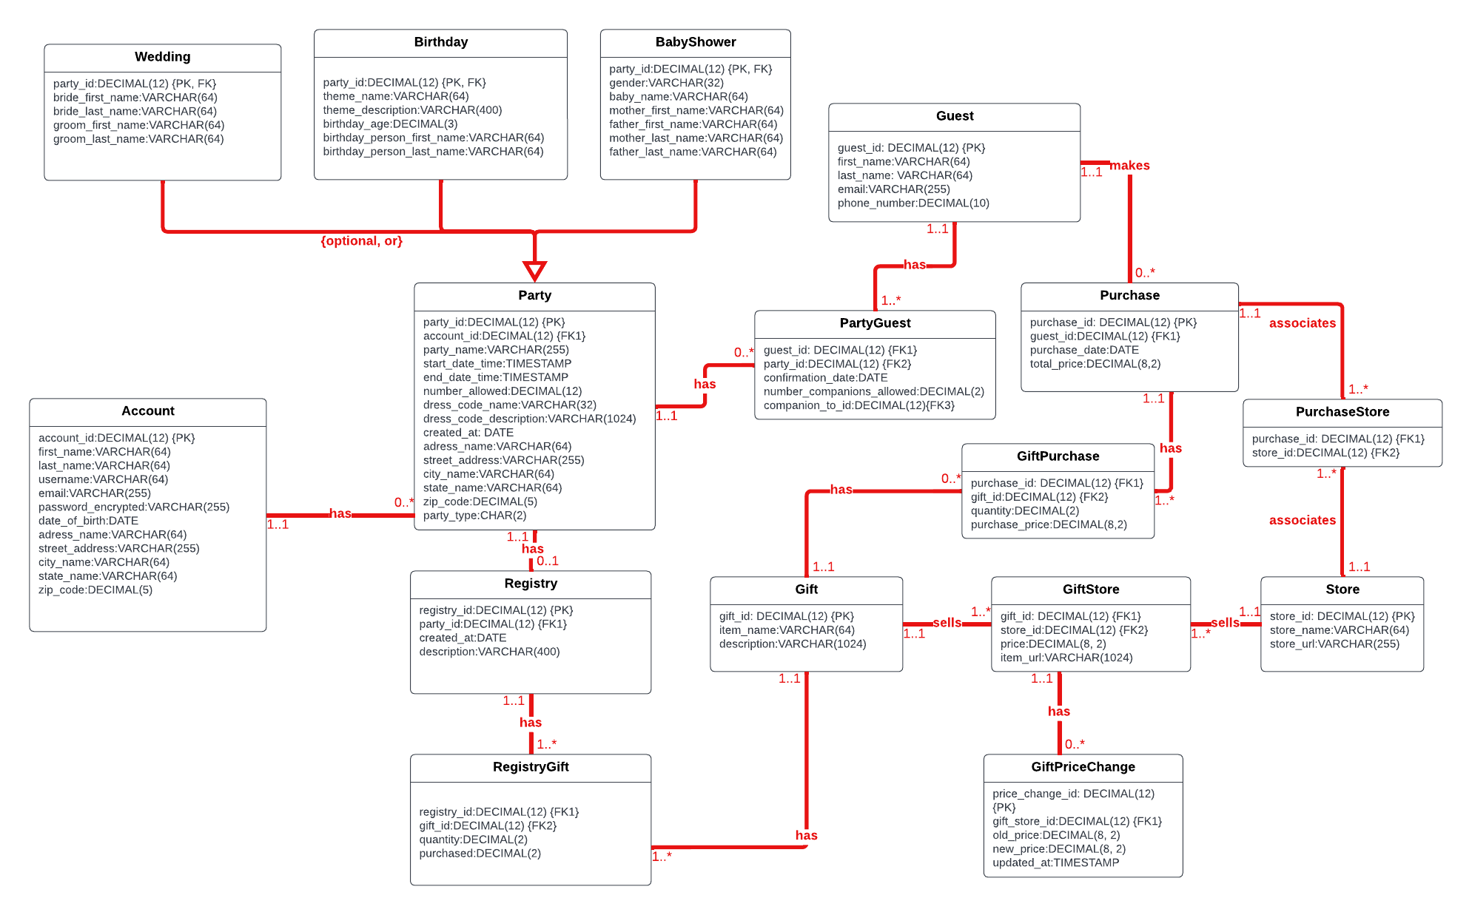

I opted to use decimal numbers of 12 digits as primary keys because that allows the system to automatically create a new key just by adding 1 to a previous key, and it enables the database to store a huge amount of data before it reaches the 12 digits limit.

## PHYSICAL ERD - AFTER NORMALIZATION

After I added the attributes, I noticed that I can apply normalization to avoid data redundancy in a few places. The first one is the address information. The address not only keeps repeating in multiple entities (Account and Party) but may also lead to data redundancy within the same table. Therefore, I abstracted the address information into a new entity and normalized it. After the address normalization, there are 2 new entities: Address, and State. I could also break out the address even more but I decided to not increase the complexity any further. Therefore, Address is not normalized to BCNF but it is the only entity that is not.

Another place that needs to be normalized is the dress code information. To avoid data redundancy in the Party table, I abstracted the dress code information into a DressCode table. By moving the dress code information to its own lookup table, this information won't repeat in the Party table for parties that have the same dress code.

Additionally, the BabyShower baby_gender attribute can be normalized to its own table. The gender information would keep repeating in the BabyShower table, so I created a new entity called Gender to hold the gender information. The same thing is happening in the Birthday table. Different parties could have the same birthday theme, and the same theme would repeat unnecessarily in the Birthday table. To avoid data redundancy, I created the Theme entity and moved the theme information there.

To sum up, after normalization, there are a total of 5 additional entities: Address, State, DressCode, Theme, and Gender.

The new relationships added with the additional entities are captured in the following classifications:

1. Account/Address is 1:1. An account is associated with an address.An address can be associated with an account.
2. Address/Party is 1:M. A party is associated with an address. An address can be associated with multiple parties
3. DressCode/Party is 1:M. A party may have a dress code. A dress code is associated with many parties
4. Theme/Birthday is 1:M. A Birthday party may have a Theme. A Theme may be associated with many Birthday parties.
5. Gender/BabyShower is 1:M. The baby shower's baby may have a gender. The gender may be associated with many baby shower's babies.
6. State/Address is 1:M. An Address is associated with a State. A State may be associated with many addresses

Here is the ERD normalized to BCNF (except Address):

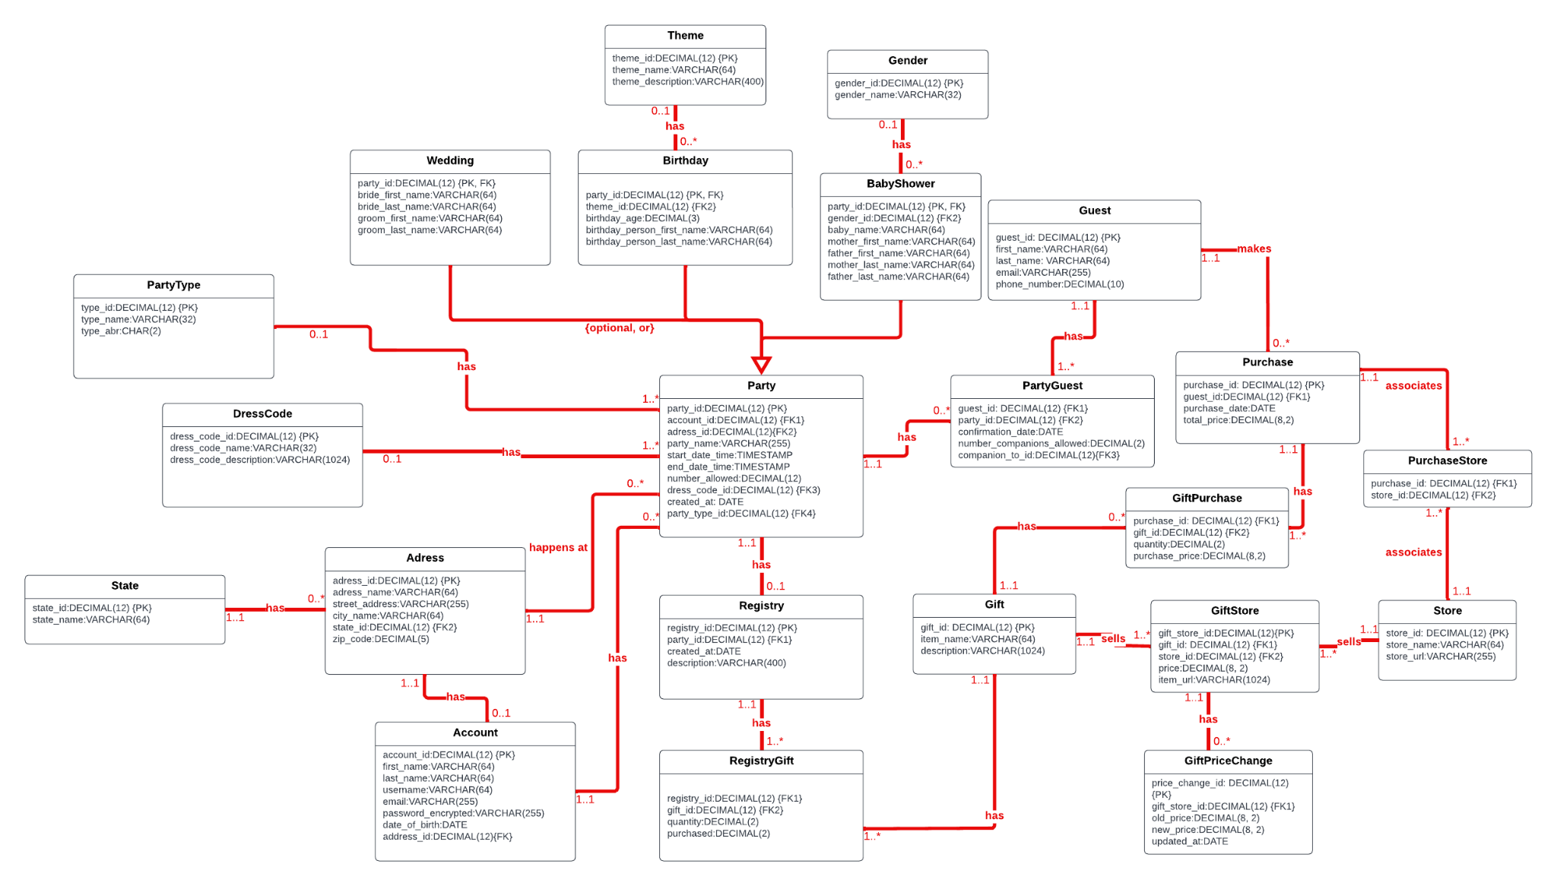

# 

# 

# Stored Procedure Execution and Explanations

To implement the use cases in this project, I created reusable stored procedures using Postgres, so that the application can execute them with the correct parameters.

The first use case is the Creating an Account Use Case. The steps are listed below:

1.1 The person visits the app store and installs the BeMyGuest application

1.2 The app asks them to create an account

1.3 The person enters their information and the account is added to the database

1.4 The app takes the new user to a dashboard page with an "add new party" button.

To handle this use case, I implemented a transaction that creates an account defined in a stored procedure. However, to create an account, the user needs to provide his/her address information. The address also needs the States tables to be populated. The State table is a domain/lookup table, so I created a stored procedure to insert a state into this table:

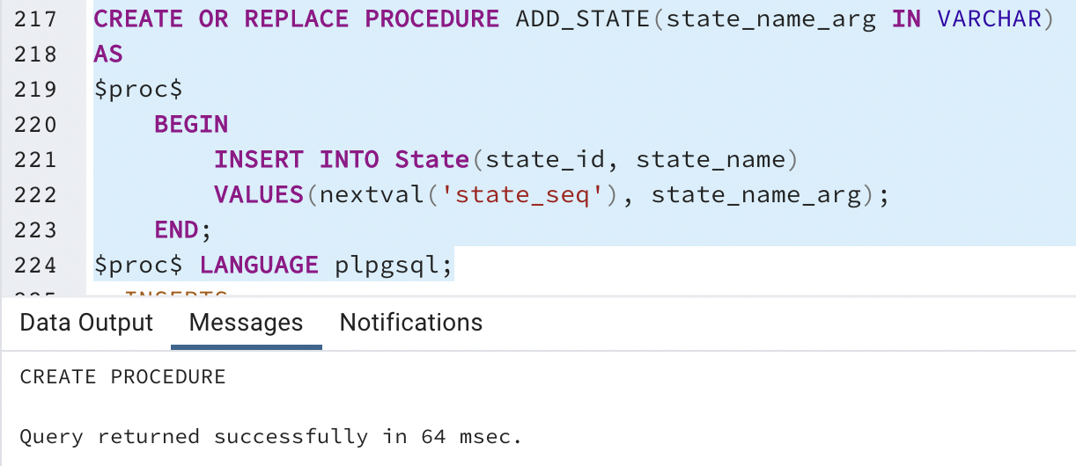

To make sure that we are not inserting an invalid state name into the State Table, I created a trigger to validate the state name so that it does not contain a number. The screenshot below shows the invalid_state_trig creation:

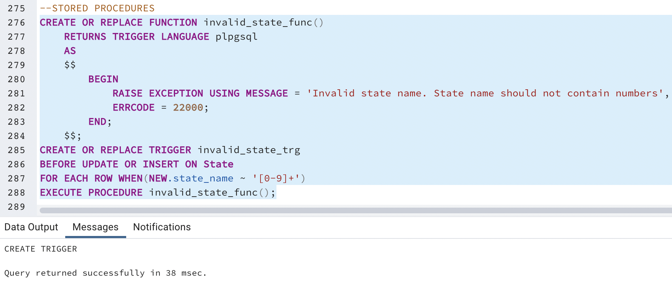

Before we execute the ADD_STATE stored procedure, the State table is empty:

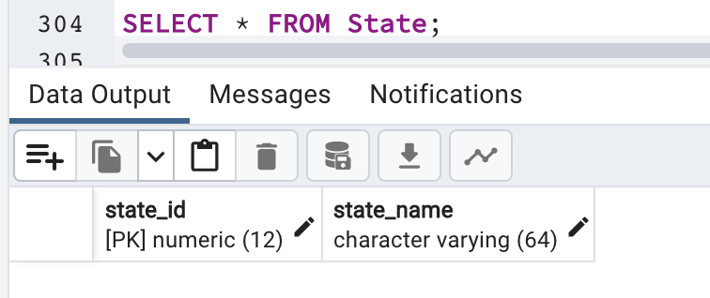

To populate the table with the 50 states, I called the procedure 50 times, passing a different state name each time:

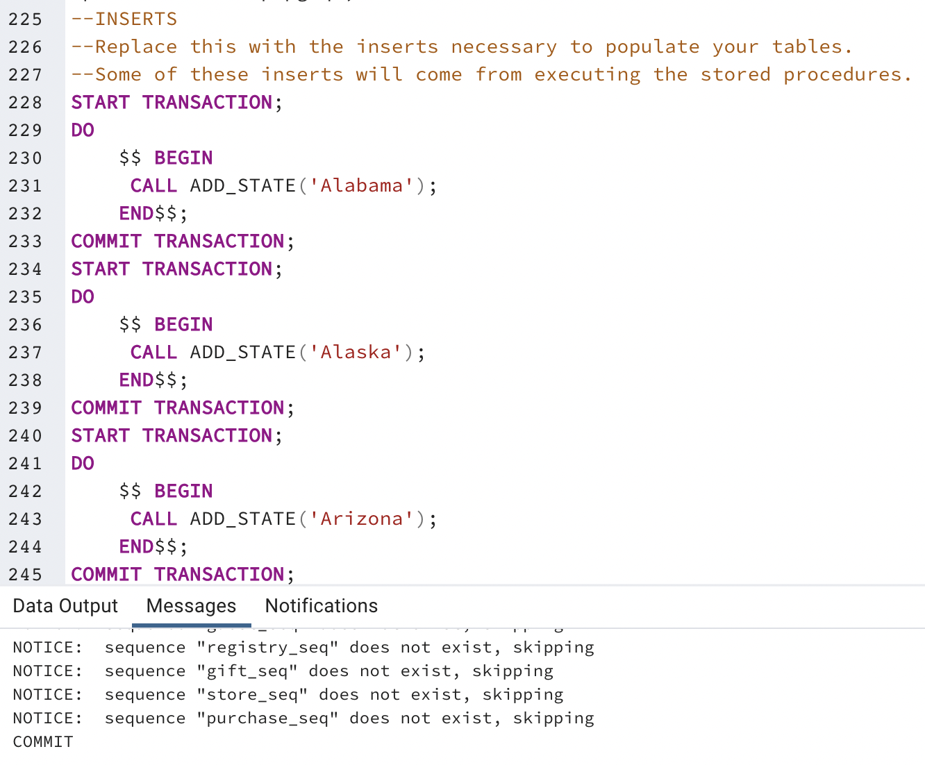

The screenshot below proves that the data has been added to the table:

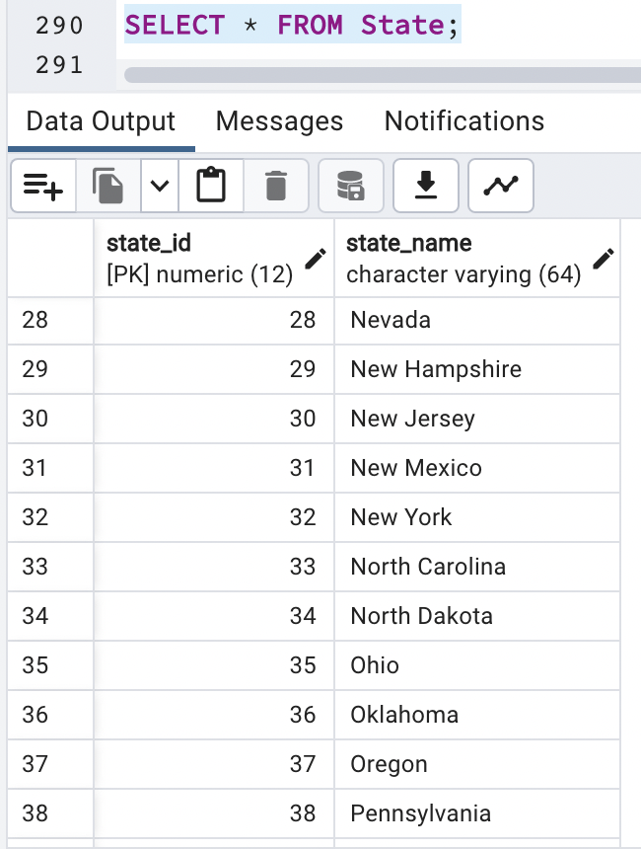

To demonstrate that the state name validation is working, I tried to add an invalid state with a name that contains numbers:

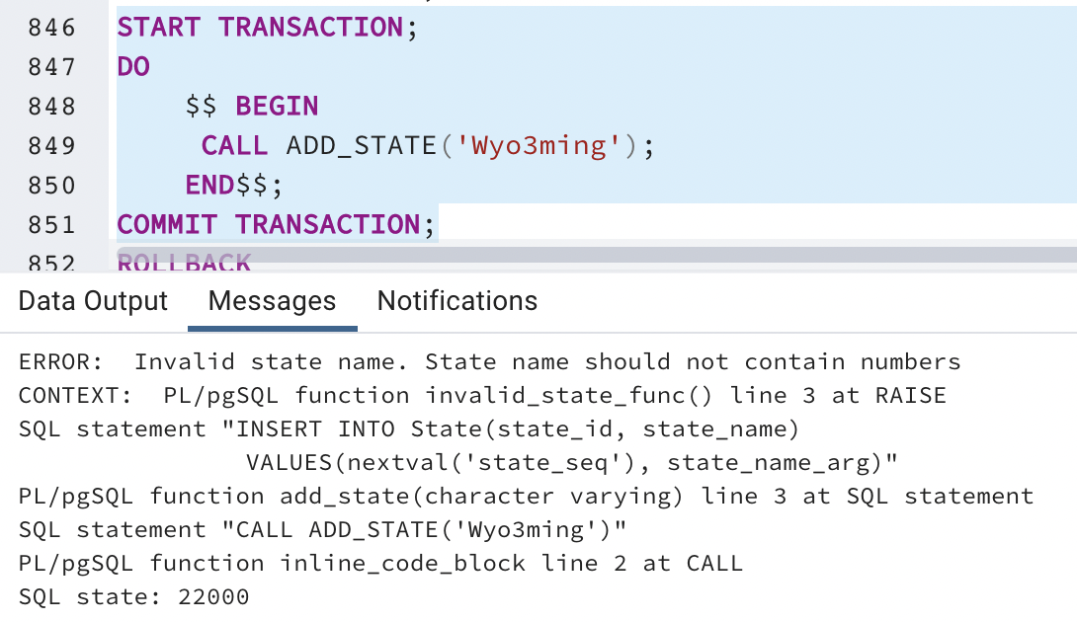

Now that the State table is completed, I created another stored procedure to implement the person creating an account use case:

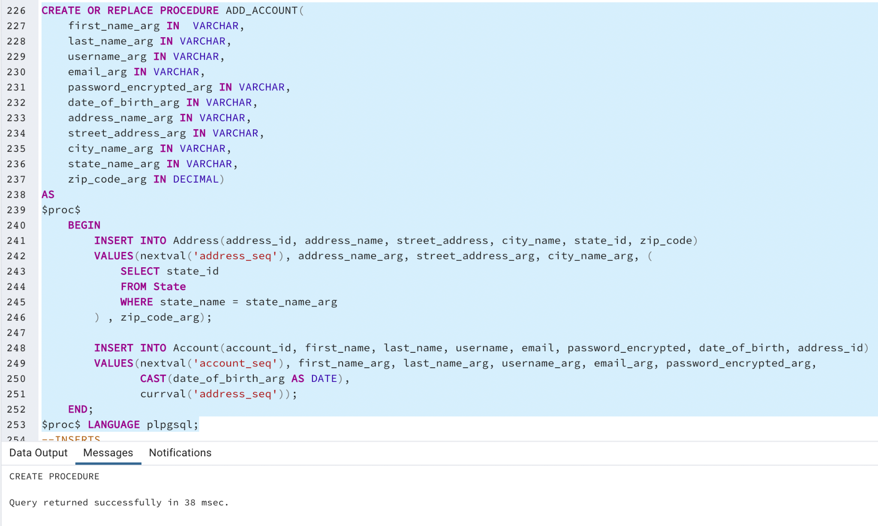

When a person creates an account, he/she needs to provide the address. Since the Account entity depends on the address id, I first inserted the values in the Address table, then I inserted the values into the Account table using the current value of the address sequence as a foreign key to the address just added. For the state_id argument in the Address table, I used a subquery to retrieve the state_id of a specific state since the parameter passed is the name of the state. I named this stored procedure ADD_ACCOUNT and the parameters correspond to the columns of the Address Table and of the Account Table.

To illustrate the execution of this stored procedure, before it is executed the Account table and the Address table are empty:

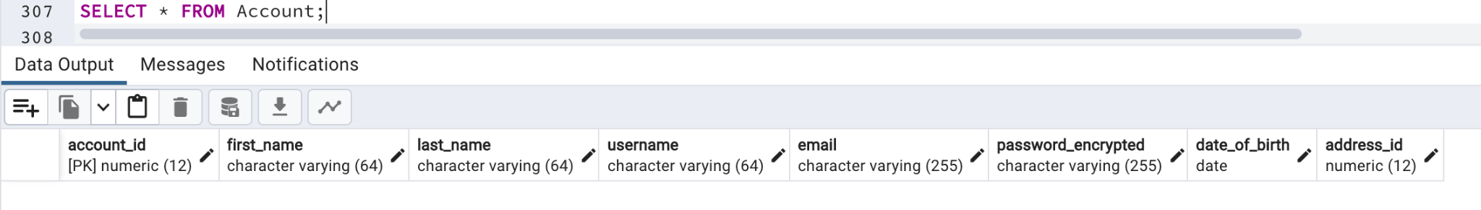

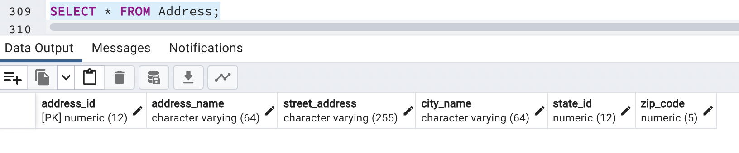

I executed the ADD_ACCOUNT stored procedure using fictional data within a transaction block to make sure the transaction is committed. You can see its execution in the screenshot below:

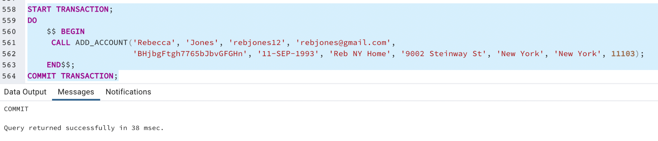

The data was correctly inserted into the Account table and Address table as you can see below:

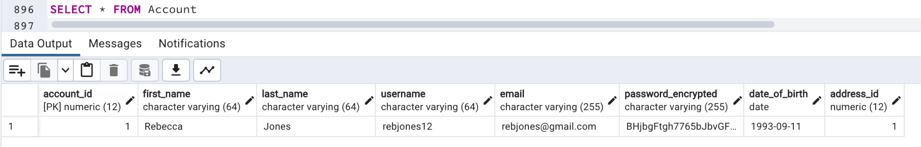

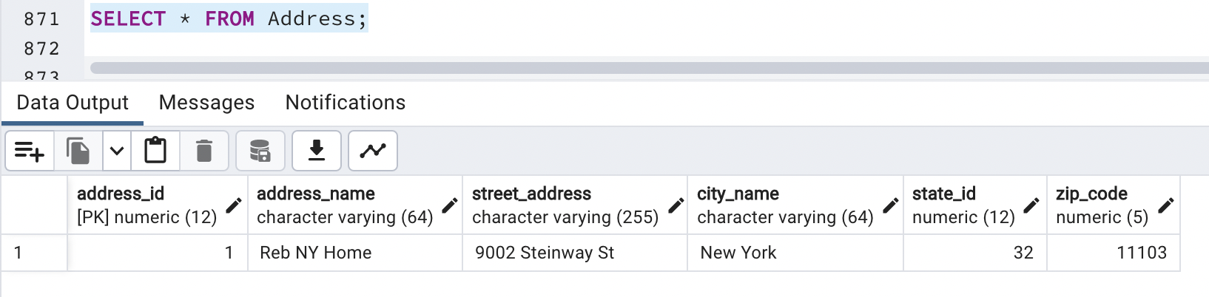

Just like for the State, the account holder's first name and last name cannot contain numbers. Therefore, I created another trigger to validate the data to be inserted or updated into the Account table:

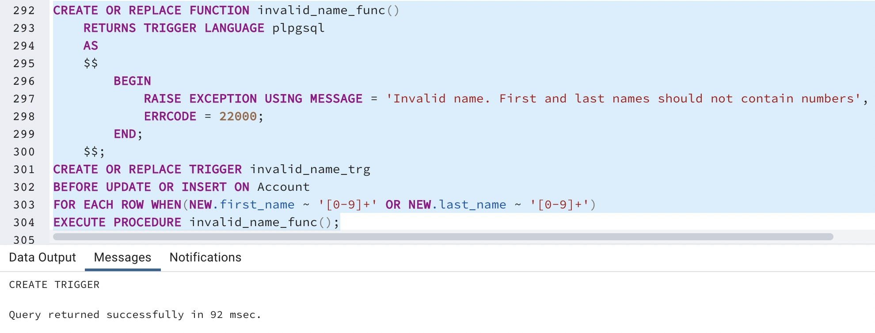

To demonstrate that the validation of the first and last names is working, I tried to insert data with the first name argument containing a number:

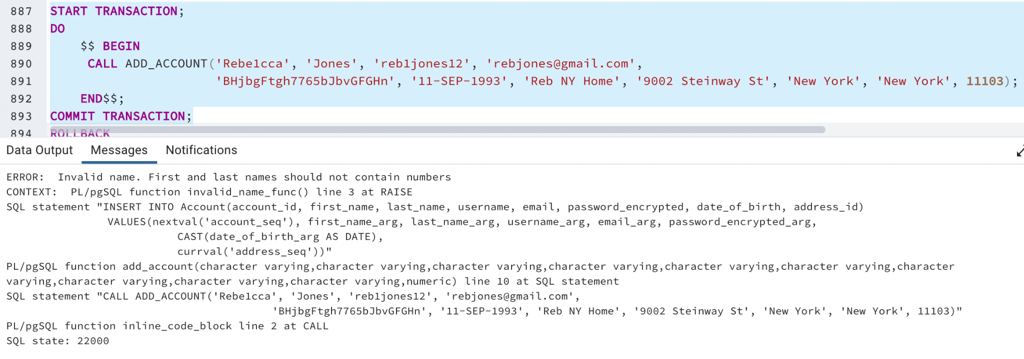

I did the same with the last name containing numbers, and the transaction failed as expected:

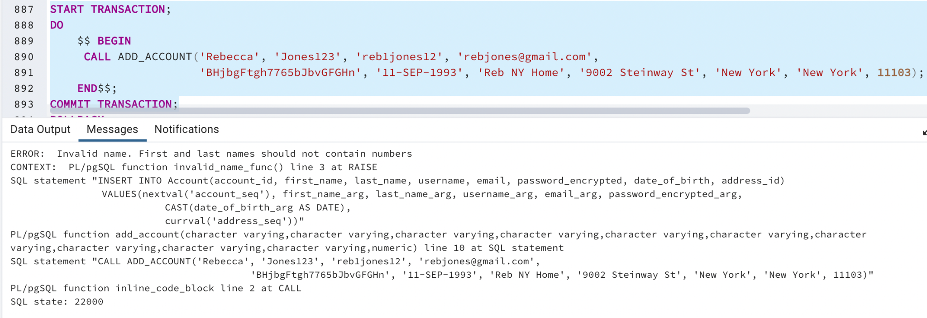

The second use case is the Creating a Party Use Case. The steps are listed below:

2.1 Assuming the account holder is logged in, when the account holder clicks on the "create new party" button, a form with the party information displays on the screen

2.2 The account holder fills out the form with the party information and selects what kind of party this is: wedding, birthday, or baby shower.

2.3 The account holder submits the form and the party information is added to the database

To handle this use case, I implemented a stored procedure to create a Party. The party can be of 3 types so far, a Wedding, a Birthday, or a Baby Shower. Therefore, each party type will be created in its own stored procedure because when the user creates a Party, we have to add the information he/she provided to both Party and the specific party tables.

The following screenshot shows the stored procedure for creating a Wedding Party: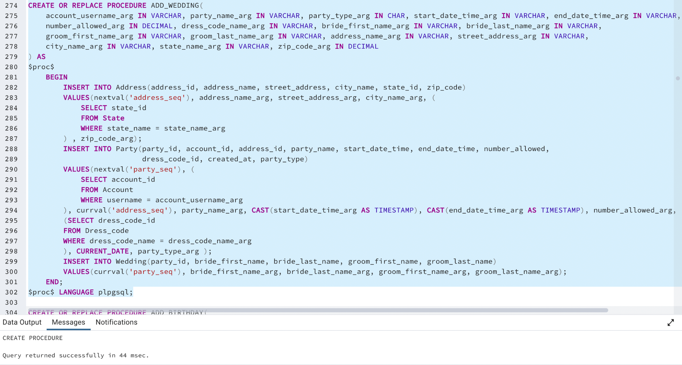

As you can see in the screenshot above, the ADD_WEDDING stored procedure inserts the information provided by the user into 3 tables: Address, Party, and Wedding. We first insert the address information into the Address Table. Then, we insert the party information into Party using the current value of the address sequence, and the CURRENT_DATE value in the created_at column. At last, we insert the wedding specific information into the Wedding table, using the current value of the party sequence as the party_id.

To add a new row into the Wedding table, we need the Dress_code table to be populated. Therefore, before we can execute the ADD_WEDDING stored procedure, we must populate the Dress_code table. To do so, I created a stored procedure called ADD_DRESS_CODE and executed it in three transactions to add three dress code types:

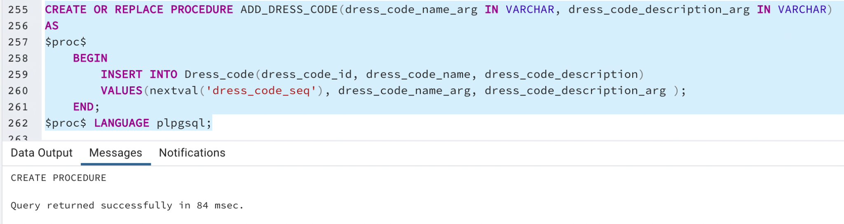

Before I executed this stored procedure, the Dress_code table was empty:

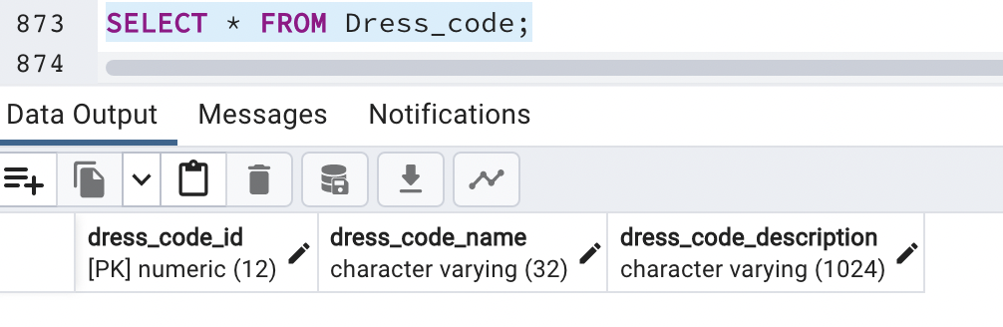

I executed the ADD_DRESS_CODE stored procedure with 3 dress code types:

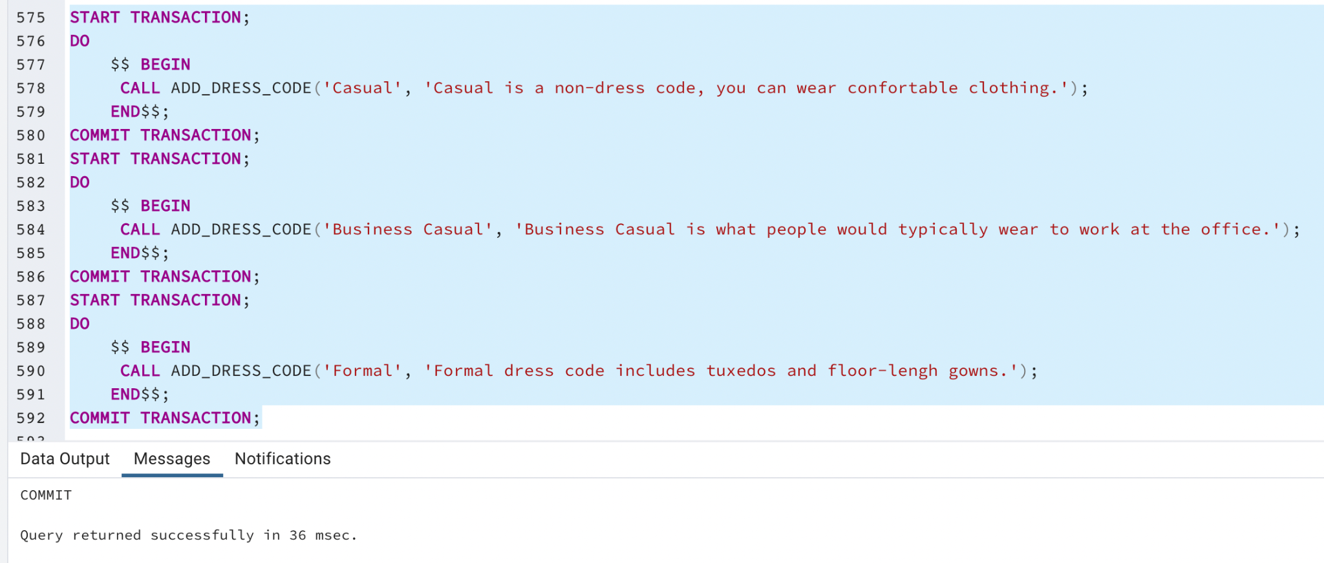

The Dress_code table now contains the data added:

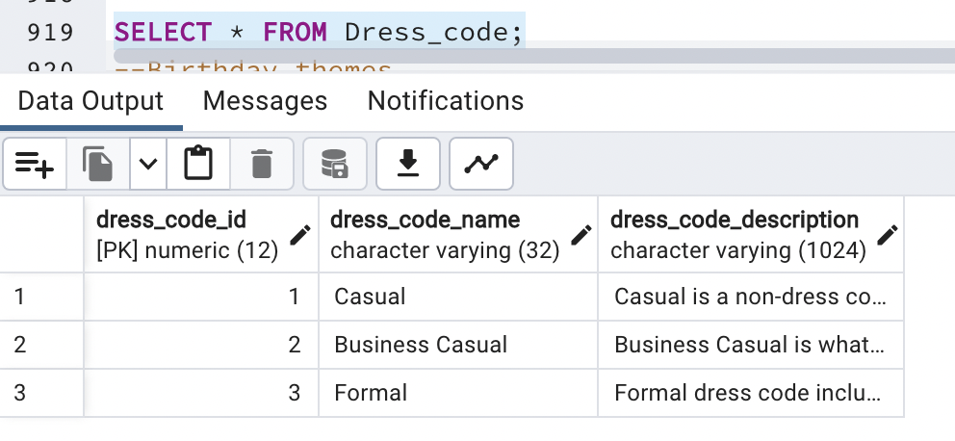

Now that we have some data in the Dress_code table, we can execute the ADD_WEDDING stored procedure with some fictional data:

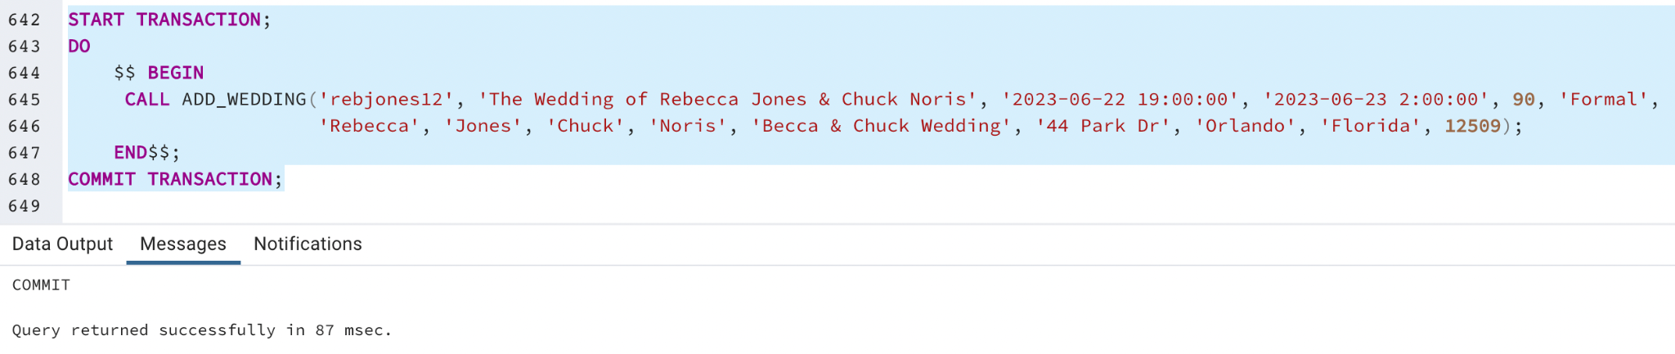

To prove that the data was correctly added, the Party table and the Wedding table are shown below:

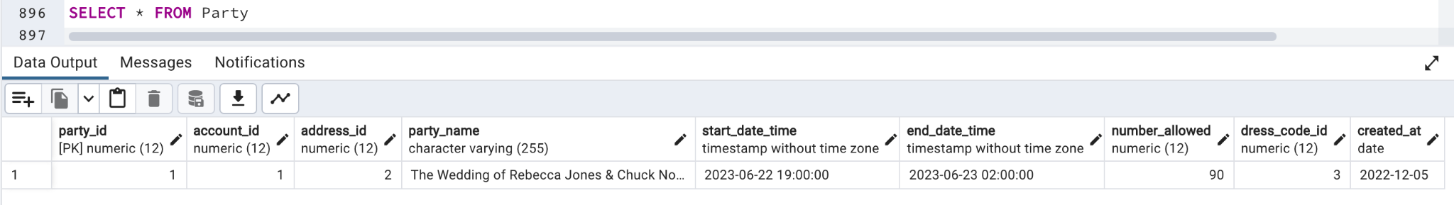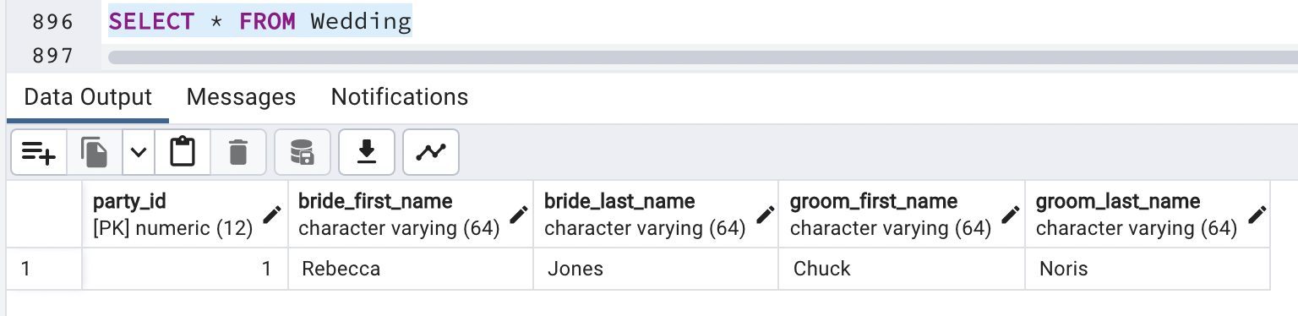

# Question Identification and Explanations

Update, if necessary, your questions useful to the organization and explanations as to why they are useful.

## Question 1 - List of confirmed Guests

The BeMyGuest app must answer the following question: Among the invited guests, who confirmed their presence at a party?

The users that create an account in this app are looking for a way to better manage their guest lists and gift lists to the parties they are planning to throw. Therefore, knowing who is actually going to the party is the core of this application. This information will certainly help the user to plan the food, entertainment, tables and chairs accordingly for the number of confirmed guests. Additionally, the user can use this list to check who is going and who is not. Furthermore, the user can use the confirmation list at the entrance of the party to allow only those with their names on the list to enter. All this is only possible if the application has a feature that shows the user a list of names of the confirmed guests.

## Question 2 - Birthday Parties for others

Another useful question to the application is: how many birthday parties does the account holder throw for other people ?

Answering this question would allow the owners of the app to know if the users have been using the birthday party type to throw parties only for themselves or if they use it to plan other people's parties too. Since the users' birthdays happen only once a year, it is more interesting for the app owners if the users used the app to plan for other people's birthdays too. With this answer the business owners can make decisions about launching marketing campaigns to motivate the users to throw birthday parties for their friends and family or creating other mechanisms to engage the users.

## Question 3 - Show gifts by category of price

Another useful question to the application is: Can the app show a list of gifts, separating them by price into 4 categories: 0-$25, $25-$50, $50-$100, $100 +?

When the guests browse the gift registry searching for a gift to purchase, one of the major factors that affect their decision is the price of the gift. Some people want to buy a lower cost gift and want to see only the gifts that cost less than $25. Other people may want to give a really nice gift and prefer to choose one that costs more than $100. The account holder can also look at the number of gifts per category to select prices with different price ranges to accommodate the price preference of the majority of the guests.

# Query Executions and Explanations

Update, if necessary, your queries answering the questions, along with screenshots and explanations.

## Question 1 - List of confirmed Guests

The BeMyGuest app must answer the following question: Among the invited guests, who confirmed their presence at a party?

The users that create an account in this app are looking for a way to better manage their guest lists and gift lists to the parties they are planning to throw. Therefore, knowing who is actually going to the party is the core of this application. This information will certainly help the user to plan the food, entertainment, tables and chairs accordingly for the number of confirmed guests. Additionally, the user can use this list to check who is going and who is not. Furthermore, the user can use the confirmation list at the entrance of the party to allow only those with their names on the list to enter. All this is only possible if the application has a feature that shows the user a list of names of the confirmed guests.

To show a list of confirmed Guests by party, I need to join the Account, Party, Party_guest, and Guest tables. The guests that have not confirmed their presence yet have NULL in the confirmation_date. Therefore, if we want to see only those guests that have already confirmed the presence, we can add a WHERE clause to the query indicating that we want to see only the guests that have the confirmation_date value different from NULL. The following screenshot shows the results of this quey:

## 

If we had not restricted the results to show only the confirmation_date value different from NULL, we would see a list of all invited guests just like in the screenshot below:

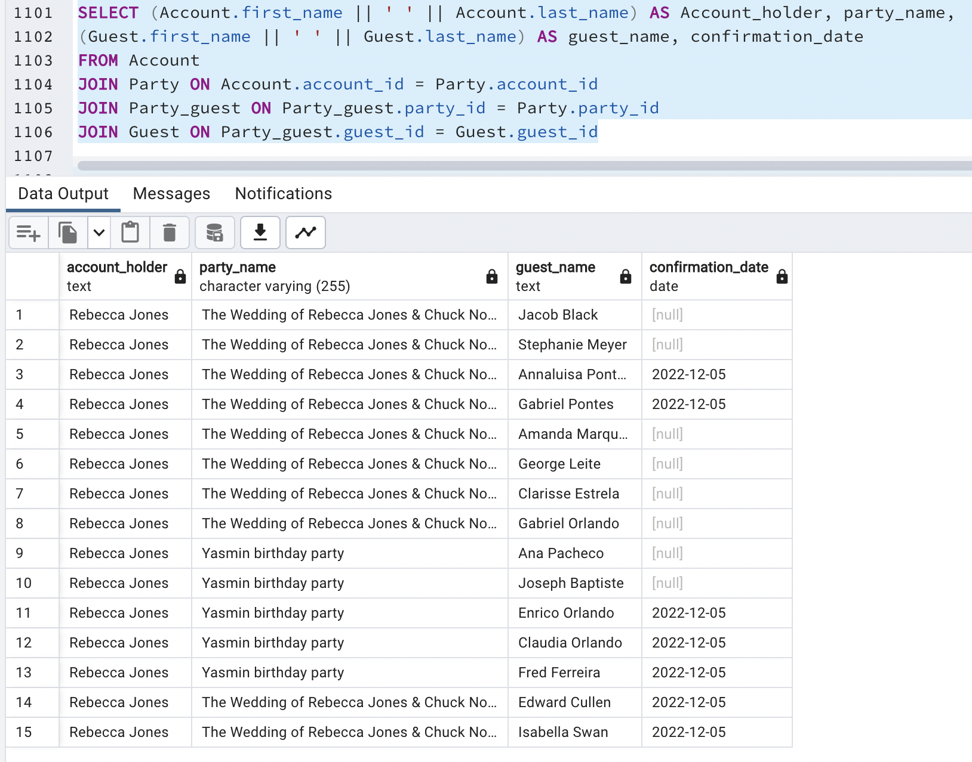

When we look at the two screenshots above, we can see that there are 10 guests invited to the Wedding party and 5 guests invited to the birthday party. However, the first screenshot shows only the guests that confirmed their presence grouped by event. For the wedding, we have 4 confirmations: Isabella Swan, Gabriel Pontes, Analuisa Pontes, and Edward Cullen. For the birthday party, we have 3 confirmed guests: Claudia Orlando, Fred Ferreira, and Enrico Orlando.

## Question 2 - Birthday Parties for others

Another useful question to the application is: how many birthday parties does the account holder throw for other people ?

Answering this question would allow the owners of the app to know if the users have been using the birthday party type to throw parties only for themselves or if they use it to plan other people's parties too. Since the users' birthdays happen only once a year, it is more interesting for the app owners if the users used the app to plan for other people's birthdays too. With this answer the business owners can make decisions about launching marketing campaigns to motivate the users to throw birthday parties for their friends and family or creating other mechanisms to engage the users.

To answer this question, we can use the following query:

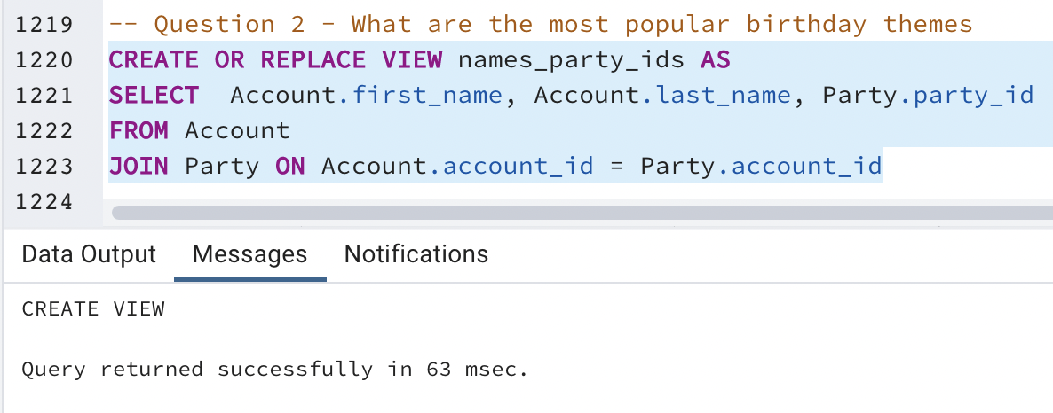

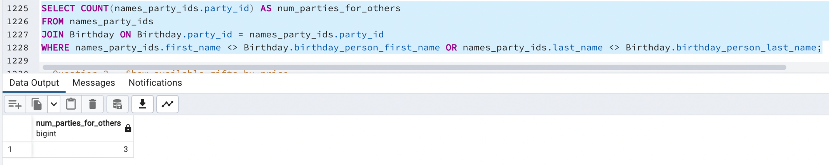

To get to this result, I joined the Account and the Party tables into a view selecting only the important columns. Since we want to know if people are creating birthday parties for others or themselves, the first_name and last_name of the account holder contain important data to answer the question.

The other part of the query, embedded on lives 1225-1228, counts the number of party ids, after joining with the Birthday table and filtering the rows where the account holder's first name is different from the birthday person first name or the account holder's last name is different from the birthday person last name. The result is correct because 3 account holders are throwing parties for other people as you can see below:

## 

## Question 3 - Show number of gifts by price category

The question we want to answer is: Can the app show the number of gifts divided into 4 price categories: 0-$25, $25-$50, $50-$100, $100 +?

To handle this question, I created a query using a view, which is a named query that we can use whenever we can use a table. I created the Gift_store_by_category view that is a table with the gift_id, category, price, and store name as columns. I already separated the prices into categories and formatted the price in this view as you can see in the screenshot below:

## 

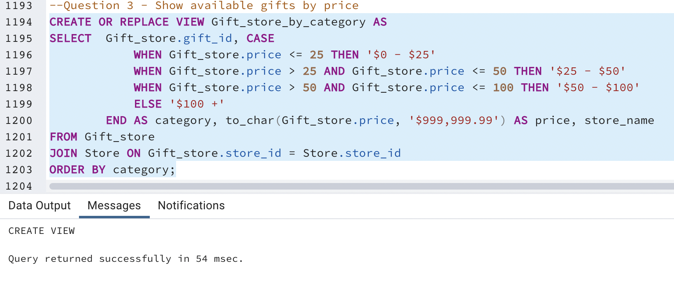

Then, I used the view to execute a query that shows the number of gifts in each category: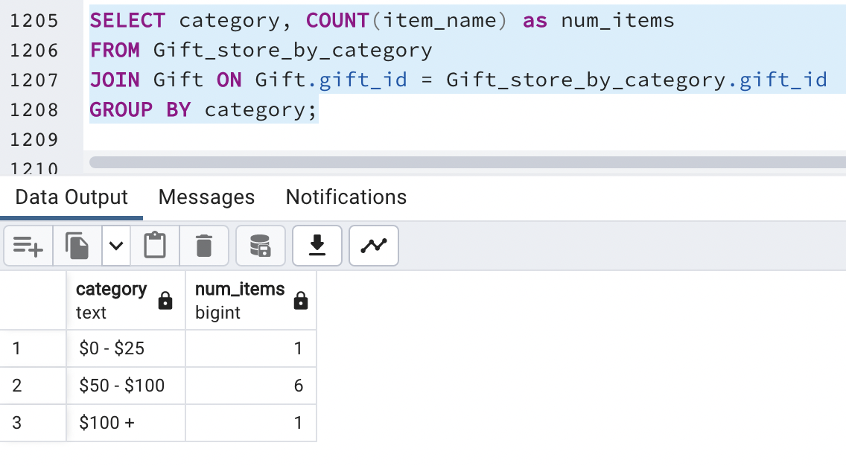

To prove that the result set is correct, I added another query that shows a list of gifts with the item names and descriptions, separated by price category. I kept the price column in this query to show that the price category is also correct:

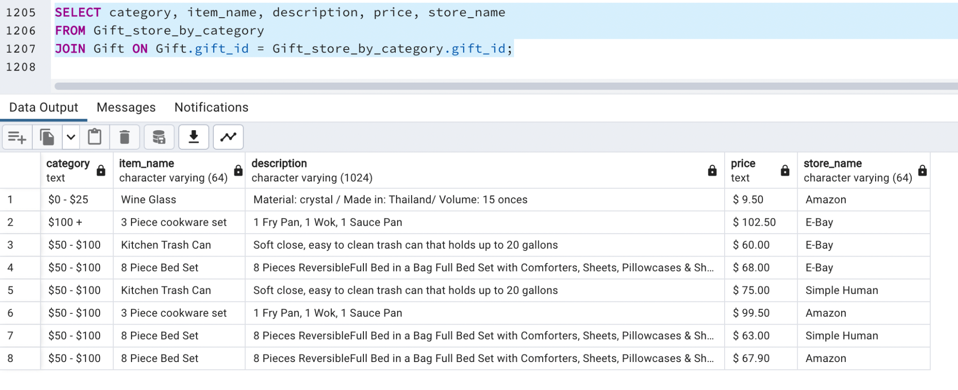

We can see in the screenshot that there are 6 items that fall into the $50-$100 category, one item that falls into the $0-$25 category, and another one that falls into the $100+ category.

# Index Identification and Creations

Update, if necessary, the indexes identifications useful to your database, explanations as to why they help, and screenshots of their creations.

Regarding the columns that need to be indexed, I will identify the primary key columns, foreign key columns, and other columns used in the WHERE clause and JOIN statements.

All the primary key columns are automatically indexed in modern databases. Here is a list of the primary keys in this project:

* State.state_id
* Address.address_id
* Account.account_id
* Party.party_id
* Dress_code.dress_code_id
* Theme.theme_id
* Gender.gender_id
* Guest.guest_id
* Registry.registry_id
* Gift.gift_id
* Purchase.purchase_id
* Store.store_id
* Gift_store.gift_store_id

The foreign keys are also indexed. Here is a list of the foreign keys:

| **Column** | **Unique?** | **Explanation** | **Index creation** |
| --- | --- | --- | --- |
| Account.address_id | unique | The address_id in Account is unique because there is only one account per address and only one address per account. |  |
| Address.state_id | not unique | The index is not unique because one state can have many addresses. |  |
| Party.account_id | not unique | One account can have many parties. So many parties may reference the same account |  |
| Party.dress_code_id | not unique | Many parties can reference the same dress code. |  |
| Party.address_id | Not unique | Many parties can happen in the same place, especially for well known event venues. So many parties may reference the same address. |  |
| Wedding.party_id | Unique | Wedding is a subtype of Party. Many weddings cannot reference the same party. Each wedding is a different party. |  |
| Birthday.party_id | Unique | Birthday is a subtype of Party. Many birthday parties cannot reference the same party. Each birthday party is a different party. |  |
| Birthday.theme_id | Not Unique | Many birthday parties may have the same theme. |  |
| Baby_shower.party_id | Unique | Baby shower is a subtype of Party. Many baby shower parties cannot reference the same party. Each baby shower party is a different party. |  |
| Baby_shower.gender_id | not unique | Many baby shower parties may reference the same gender. |  |
| Registry.party_id | Unique | Each party has only one registry and one registry is referenced only by one party. |  |
| Registry_gift. registry_id | Not Unique | The registry_id is referenced many times in the Registry_gift table because a registry may have many gifts. |  |
| Registry_gift.gift_id | Not Unique | The index is not unique because a gift can be in many registries |  |
| Party_guest.guest_id | Not Unique | A guest can go to many parties |  |
| Party_guest.party_id | Not Unique | Many guests can go to the same party, so the party_id can repeat in the Party_guest table. |  |
| Purchase.guest_id | Not Unique | The same guest can make many purchases, so the guest_id may repeat in the Purchase table. |  |
| Gift_Purchase.gift_id | Not Unique | The index is not unique because a gift can be in many purchases |  |
| Gift_purchase.purchase_id | Not Unique | The index is not unique because in one purchase, the guest can buy many gifts. So the purchase_id can repeat in the Gift_purchase table. |  |
| Gift_store.gift_id | Not Unique | The index is not unique because the same gift can be sold in different stores. So the gift_id can repeat in the Gift_store table |  |
| Gift_store.store_id | Not Unique | The index is not unique because the same store can sell different gifts. So the store_id can repeat in the Gift_store table |  |
| Purchase_store.purchase_id | Not Unique | The index is not unique because in the same purchase gifts can be purchased in different stores. So the purchase_id can repeat in the Purchase_store table |  |
| Purchase_store.store_id | Not Unique | The index is not unique because in different purchases, the guest can buy gifts in the same store. So the store_id can repeat in the Purchase_store table |  |

From the previous section, we can identify query driven indexes. The first query retrieves a list of confirmed guests. It filters the guests using the confirmation_date column from the Party_guest table. If there is no value in that column, it doesn't show that row in the result set. However, if there is a date in the confirmation_date column, it means that the guest confirmed his/her presence on that day. Therefore, the confirmation_date column should be indexed. Since many guests can confirm on the same day, this index is not unique.

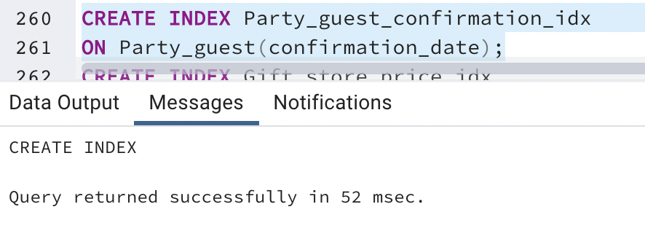

The second query returns the number of birthday parties that the user throws for other people. The query used the Account.first_name and the Account.last_name in the WHERE clause comparing it to the Birthday.birthday_person_first_name and Birthday.birthday_person_last_name to filter out the rows where the names match and return only the ones that do not match. This way we know if the account holder is throwing a birthday party for him/herself or for others. People can have the same first name or last name, that is why the indexes are not unique.

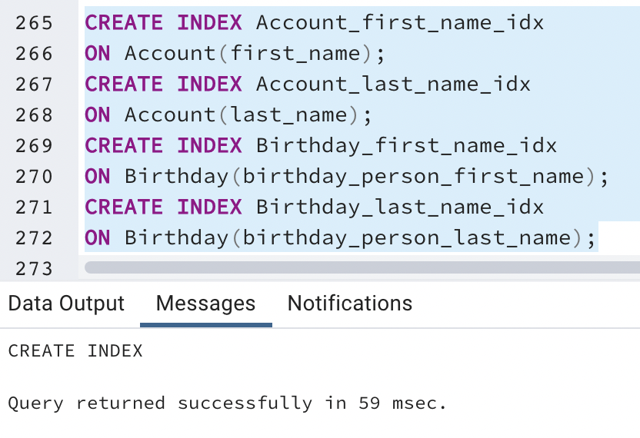

The third query retrieves a list of gifts grouped by price categories. In the Gift_store_by_category View, I used the price as a delimiter for the categories. It is reasonable to select Gift_store.price to be indexed. Since many gifts can have the same price, this index is not unique.

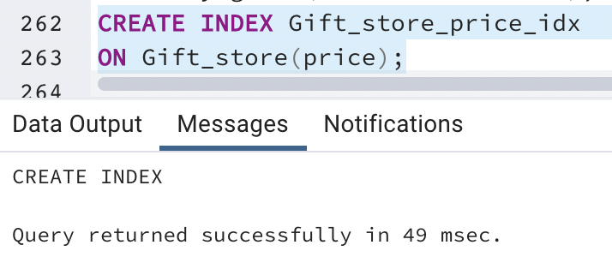

# History Table Demonstration

Explain the specifics of your history table, including how the trigger works, and demonstrate that the history table captures changes.

In this project, the data that would benefit from a history table is the price attribute of the GiftStore table. By knowing the price history of the gifts sold in different stores, the app can show the guests which stores are giving discounts on their products and show the price difference before and after the discount. The bigger the discount the more willing the user will be to purchase the product from that store.

I added the database structural rule number 17 to the Database Structural Rules section in this document to capture the relationship between the Gift and the GiftPriceChange, which is the gift price history table. The rule is: A gift sold in a store may have many price changes (optional, plural). A price change is associated with one gift sold in a store (mandatory, singular). You can see an explanation in the Database Structural Rules section.

I updated the conceptual ERD and Physical ERD to reflect the addition of the GiftPriceChange entity. The GiftPriceChange entity's attributes are:

| **attribute** | **datatype** | **description** | **example** |
| --- | --- | --- | --- |
| price_change_id | DECIMAL(12) | This is the primary key that identifies a unique and not null value for each insert in the history table. As mentioned earlier, all primary keys are DECIMAL(12) to allow many values. | 2 |
| gift_store_id | DECIMAL(12) | This is the foreign key that references the Gift_store table and the row that had the change in price. | 3 |
| old_price | DECIMAL(8,2) | This is the price of the gift before the change. The data type is the same as the GiftStore.price | 55.60 |
| new_price | DECIMAL(8,2) | This is the price of the gift after the change. The data type is the same as the GiftStore.price | 60.50 |
| updated_at | DATE | This is the date the price was updated. | 2022-12-04 |

The following screenshots show the Gift_price_change table creation and the price_change_seq sequence creation, which is the sequence that determines the primary key for this table:

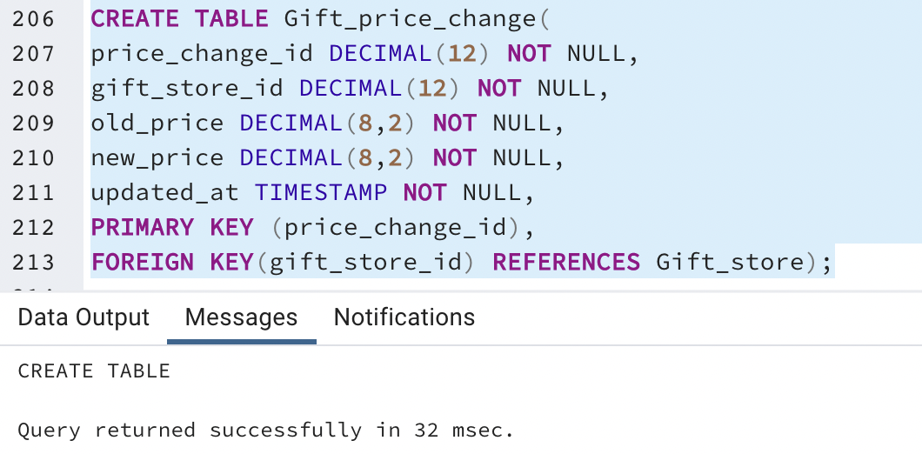

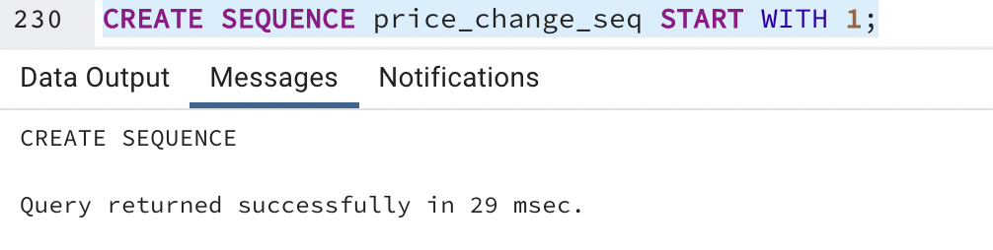

Then I created the trigger that will insert the data change into the Gift_price_change table :

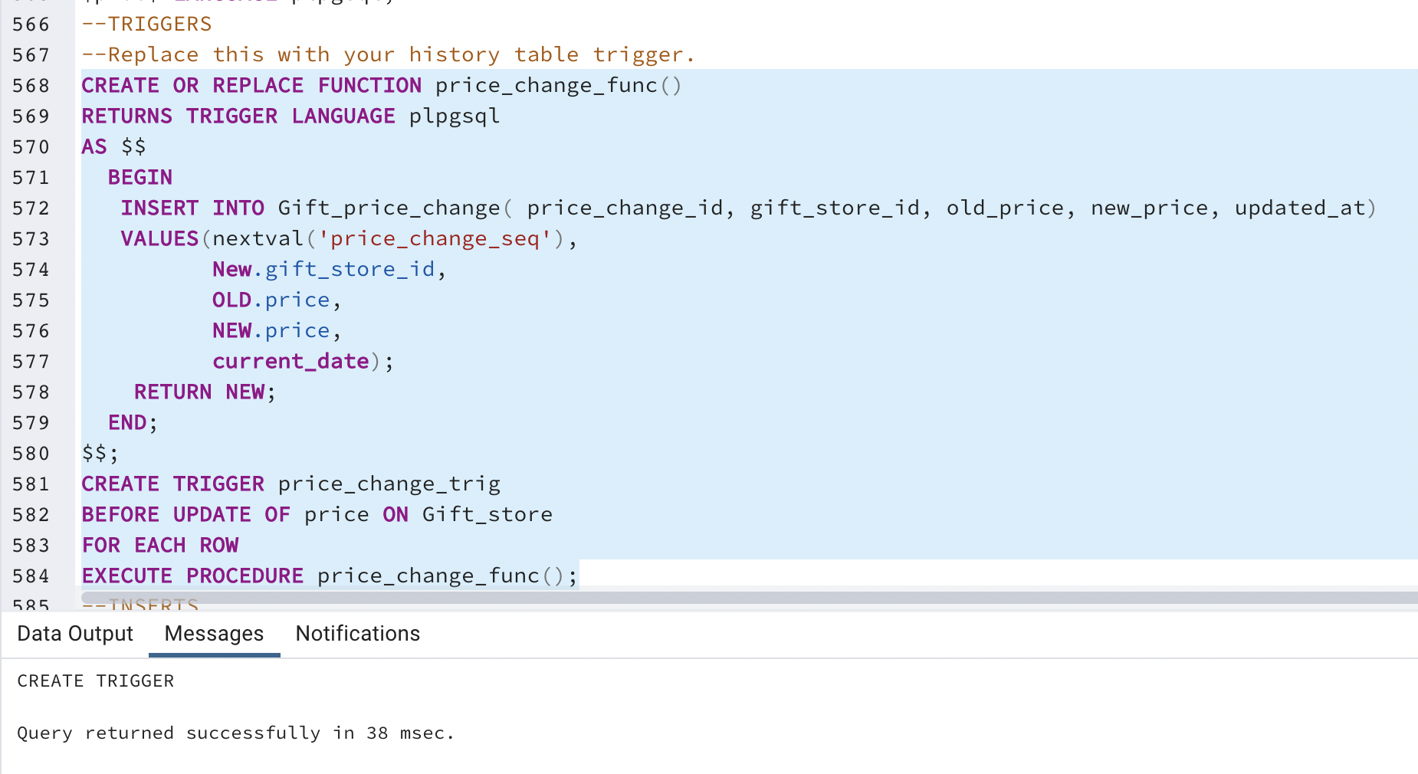

The price_change_func function is executed when the price_change_trig trigger is invoked. The trigger will always be invoked whenever the price column on the Gift_store table is updated. The trigger is responsible for adding a new row into the Gift_price_change table with the price_change_id generated by the price_change_seq sequence, the gift_store_id and the new_price coming from the NEW pseudo table provided in plpgsql triggers, and the old_price coming from the OLD pseudo table also provided in plpgsql triggers. The updated_at attribute receives the current date as value because the trigger fires right before the update in the price column of the Gift_store table.

To test the Gift_price_change history table, I inserted 8 gifts to the Gift_store table. To do so, I first created a Party associated with the account previously created:

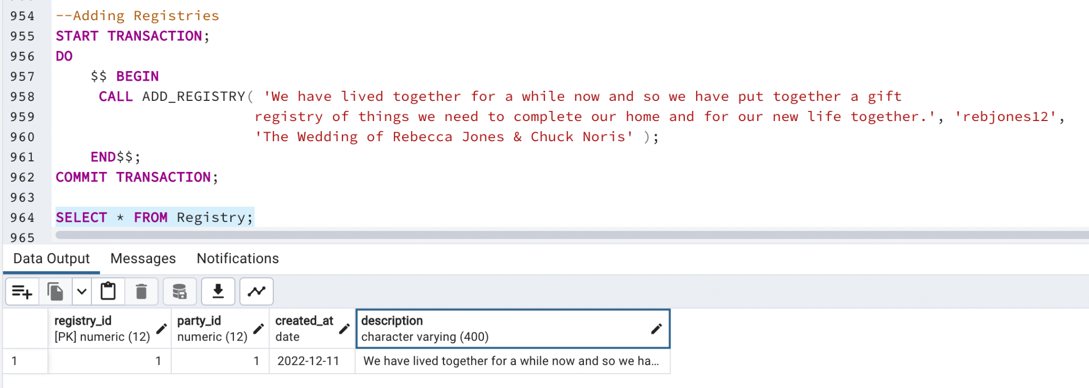

Then, I added a registry associated with this party: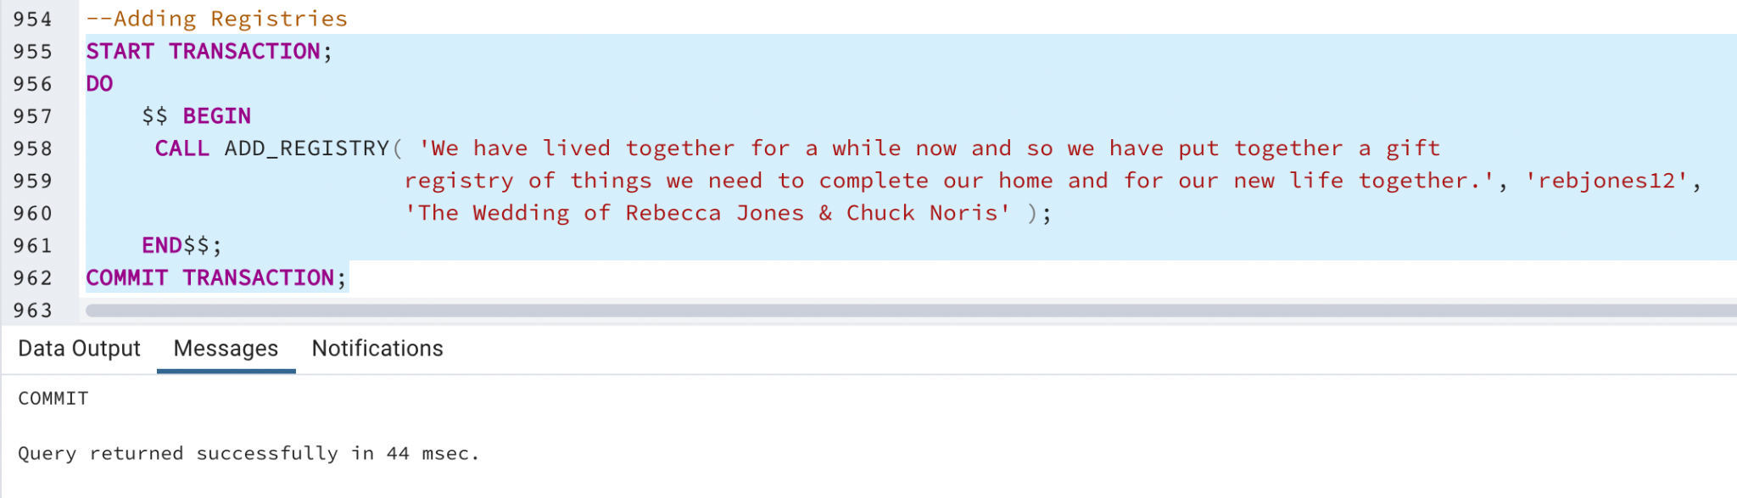



The next step is to add gifts to this registry:

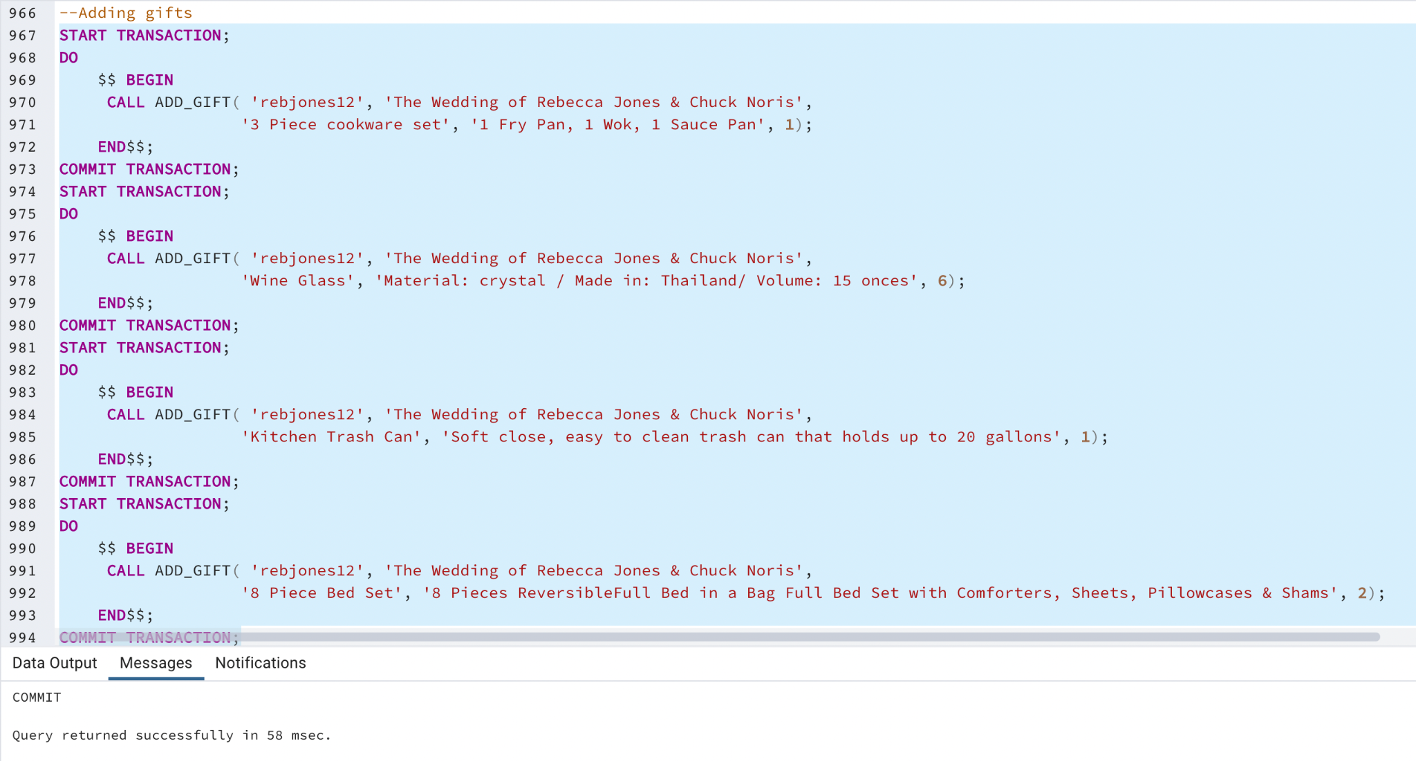

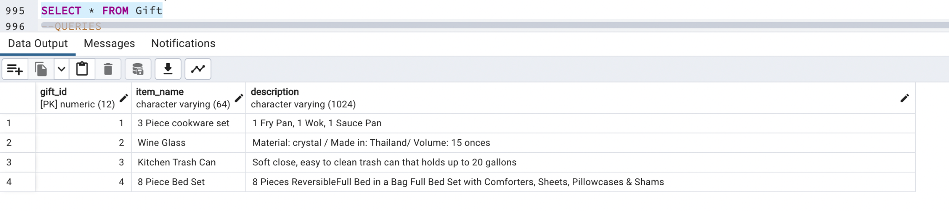

Now we need to add the stores:

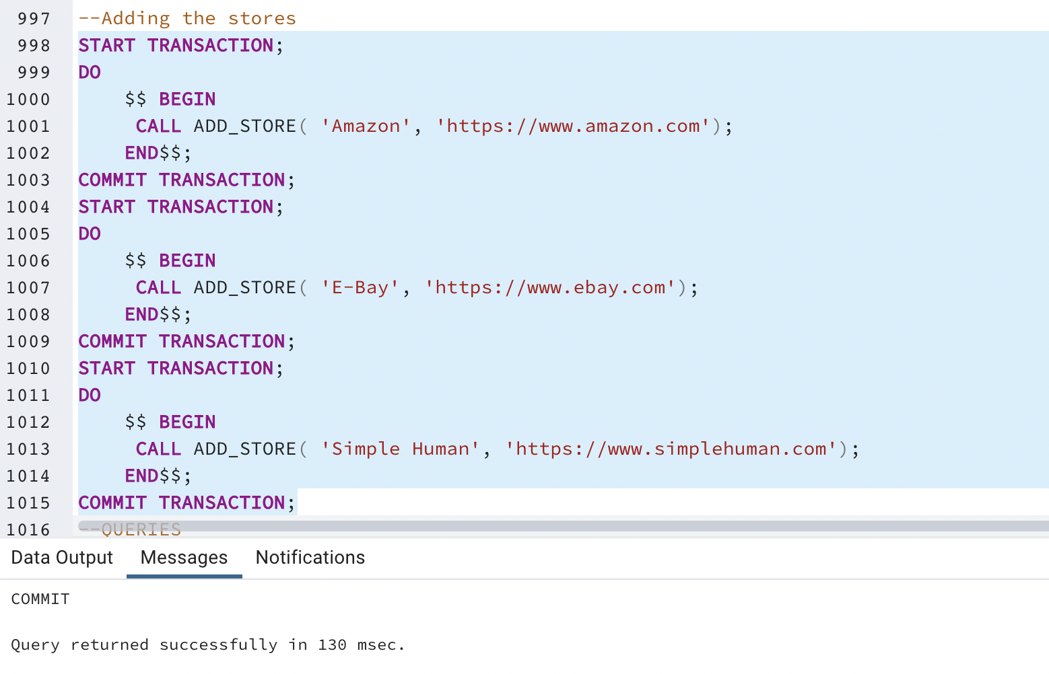

After adding the stores, I associated the gifts with the stores that sells them:

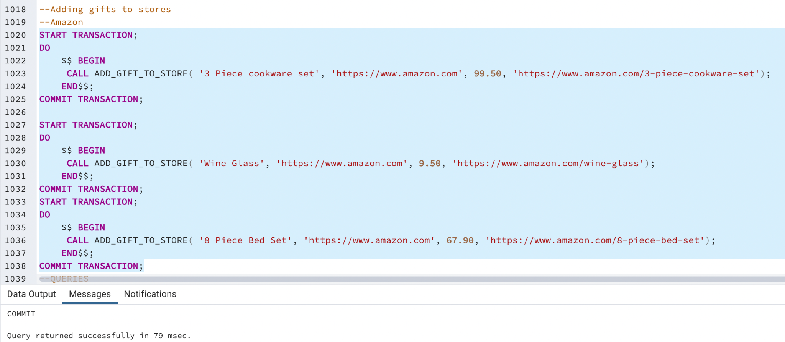

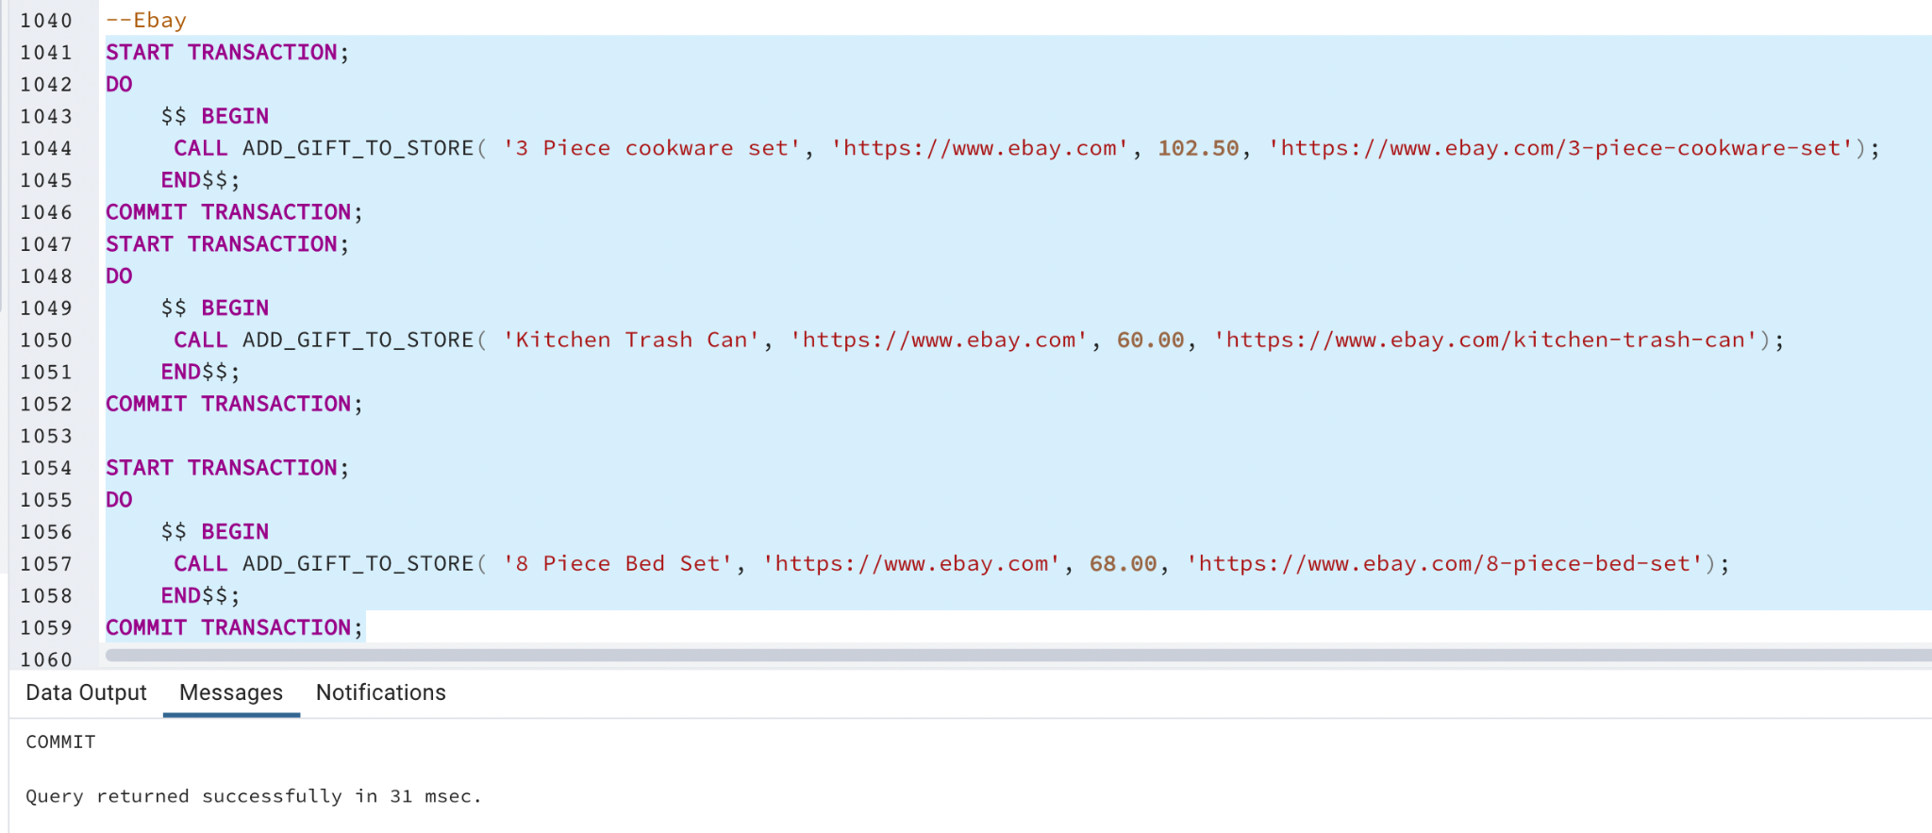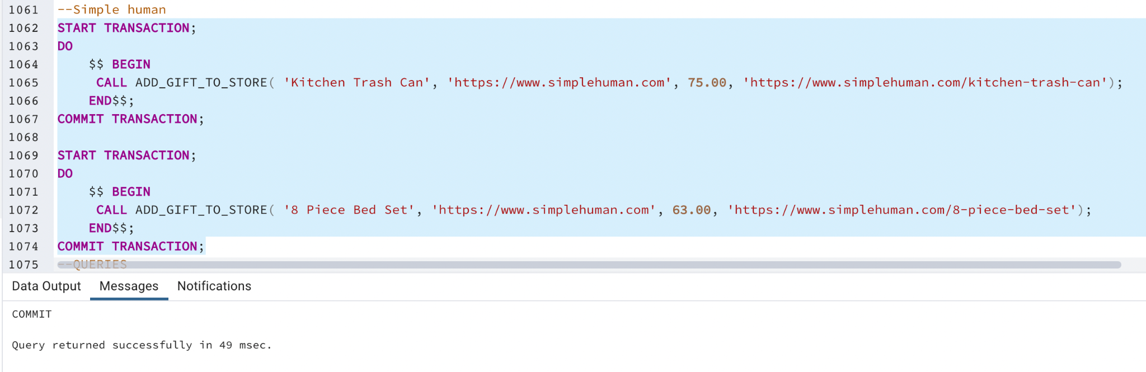

To prove that the gifts and the stores were correctly associated with each other, the next screenshot shows the data in the Gift_store table:

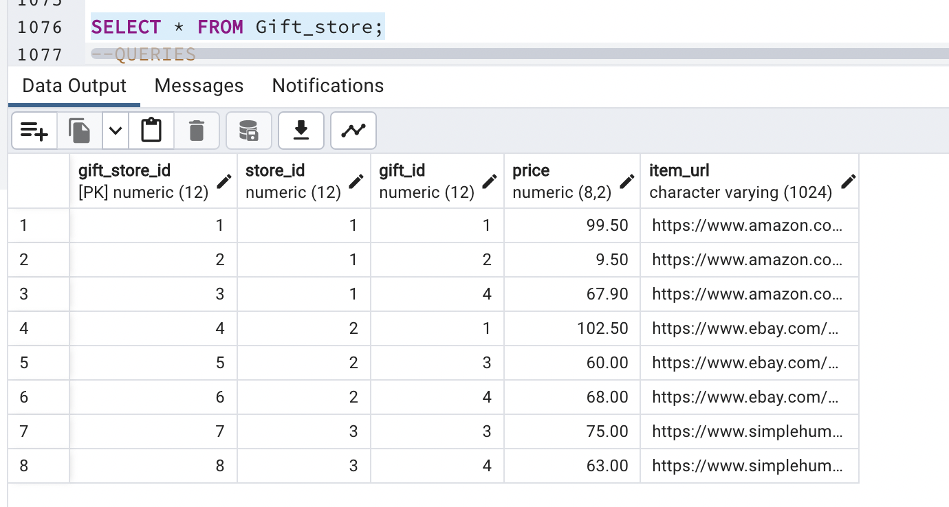

Initially, the Gift_price_change table is empty because the prices haven't been updated yet, as you can see in the screenshot below:

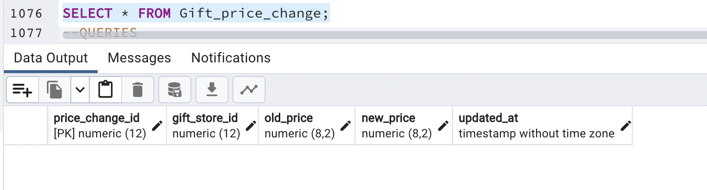

To test if the trigger is adding the correct data into the Gift_price_change table, I updated some of the Gift prices in the Gift_store table:

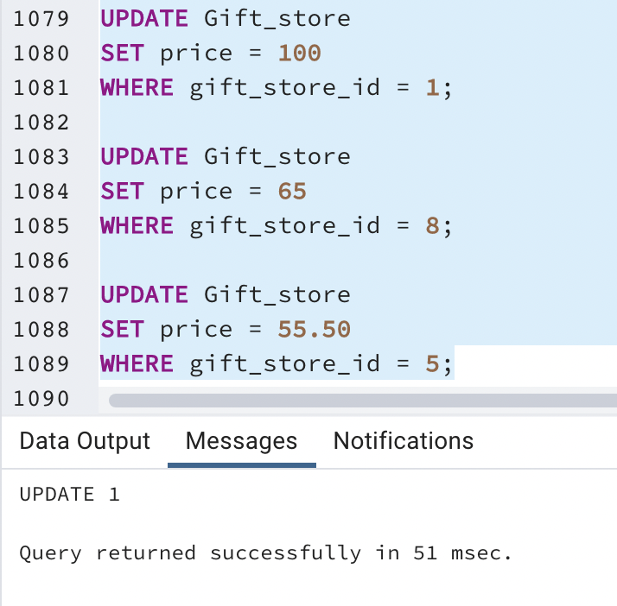

The following screenshot shows the Gift_price_table after the updates:

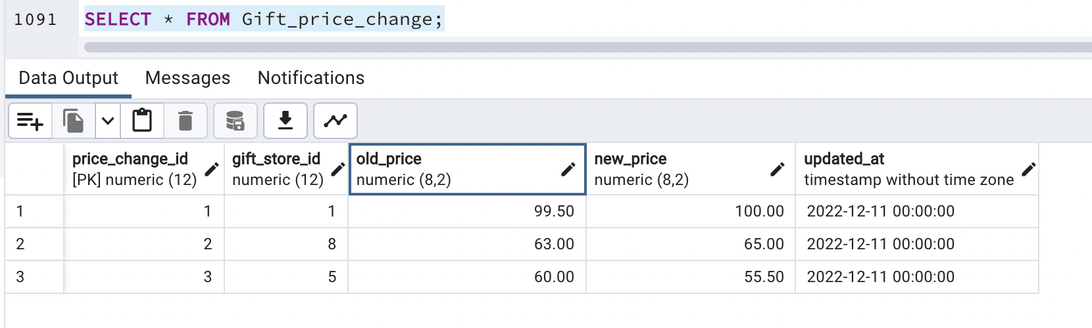

I even updated one of the gifts again, the one with gift_store_id equal to 1, to prove that the price changed correctly on the first update.

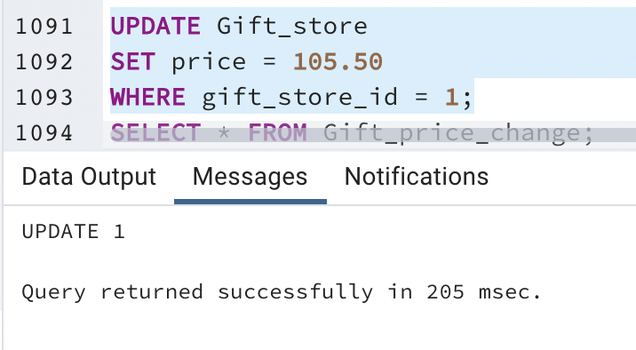

As you can see below, in the first row the price changed from 99.50 to 100.00. Then on the fourth row, the price changed from 100.00 to 105.50:

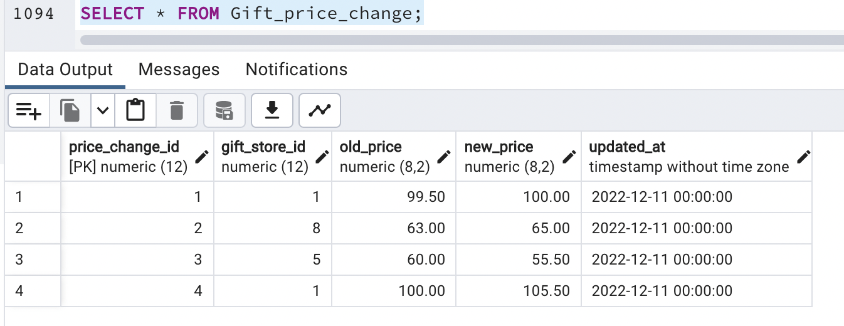

As you can see above, all the price changes were correctly recorded in the Gift_price_change history table.

# Data Visualizations

Include and explain data visualizations and stories that tell effective stories about the information in a way that people quickly and accurately understand it.

## Data Visualization 1

*Question: What is the users' favorite type of party?*

The BeMyGuest app allows users to create a party of one of 3 types: Wedding, Birthday, and Baby Shower. The app's UI must be developed to accommodate each party's specific features and attributes. It is important to know which party type is the most popular among the users, so the business analysts can make decisions about which party type will have more features or customizable settings based on the party types the users create the most. This way, the company's resources can be allocated to the features that will aggregate the most value, and make the users experience even better.

The following simple query can answer that question:

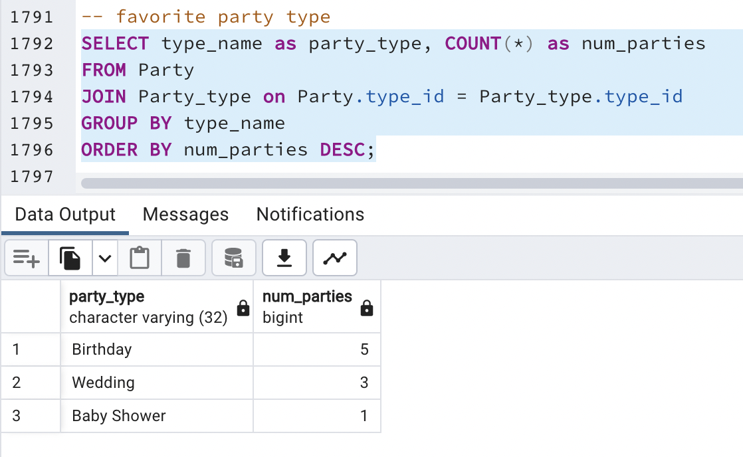

This query counts the number of parties the users created of each type and returns the result in descending order. To better visualize the results, I exported them to a CSV file, and opened it on Excel. I decided to show the results in a Pie Chart because since there are only 3 types of party, this chart shows the number of each party type in relation to the total number of parties. Even with a large number of parties it is still easy to visualize which party type is the most popular.

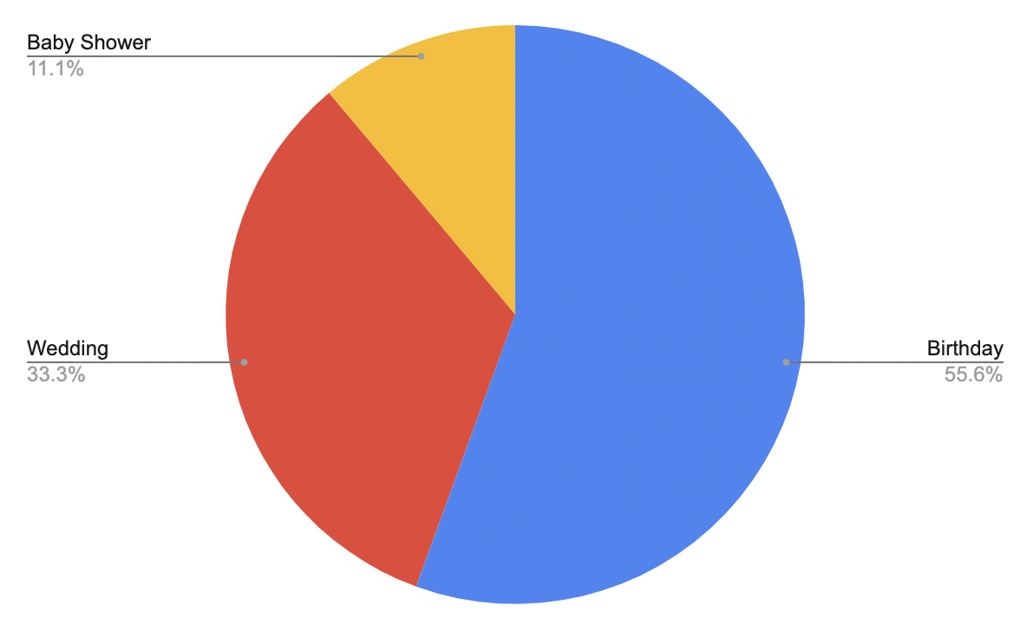

This visualization tells us that the most popular type of party is the Birthday Party, representing 55.6% of the total number of parties the users created. The second most popular type of party is the Wedding party, representing 33.3% of the total. The Baby Shower is the type of party the users created the least, representing only 11.1% of the total. The business analysts and the app's owner can use this information to decide to invest more on the birthday party type. They can decide to create more Birthday themes, or add more customizable elements to the birthday party. One day eventually they could make the decision to focus only on birthday parties if this tendency continues. Another entirely different strategy would be to invest more on the baby shower or the wedding parties. Since the users seem to be enjoying the birthday party, the business owners could decide to improve the user's experience for the Baby Shower and the Wedding types of party, or invest in marketing campaigns to engage the users to create more parties of those types.

## Data Visualization 2

*Question: What party type has the highest average number of guests?*

This question is useful because invited guests are potential new users to the platform. Therefore, knowing which type of party has the highest average number of guests could be a good path to growing our user base. Additionally, the number of guests is directly related to the number of gifts purchased. If in the future we decide to charge a percentage of the value of the gifts, parties with a large number of guests would be more likely to increase our revenue than parties with less number of guests.

To answer this question, I executed the following query:

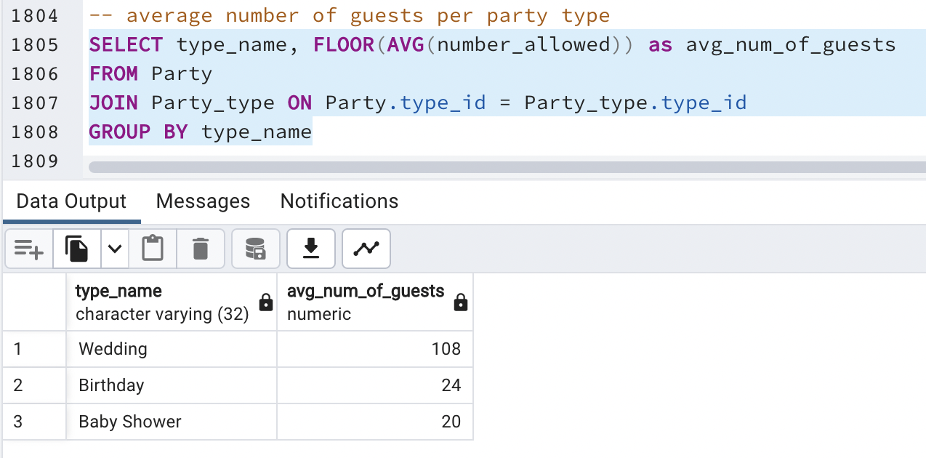

The query above calculates the average number of guests allowed per party type, returning the type name and the average. It rounds the average on the greatest integer.

As we've seen in the previous data visualization, the birthday party is the most frequent type of party on our platform today. However, the visualization below shows that on average parties of type Wedding have 5 times more guests than parties of type birthday. Therefore, if we focus our marketing efforts towards parties of type wedding, that could accelerate our user growth, potentially boosting revenue and engagement.

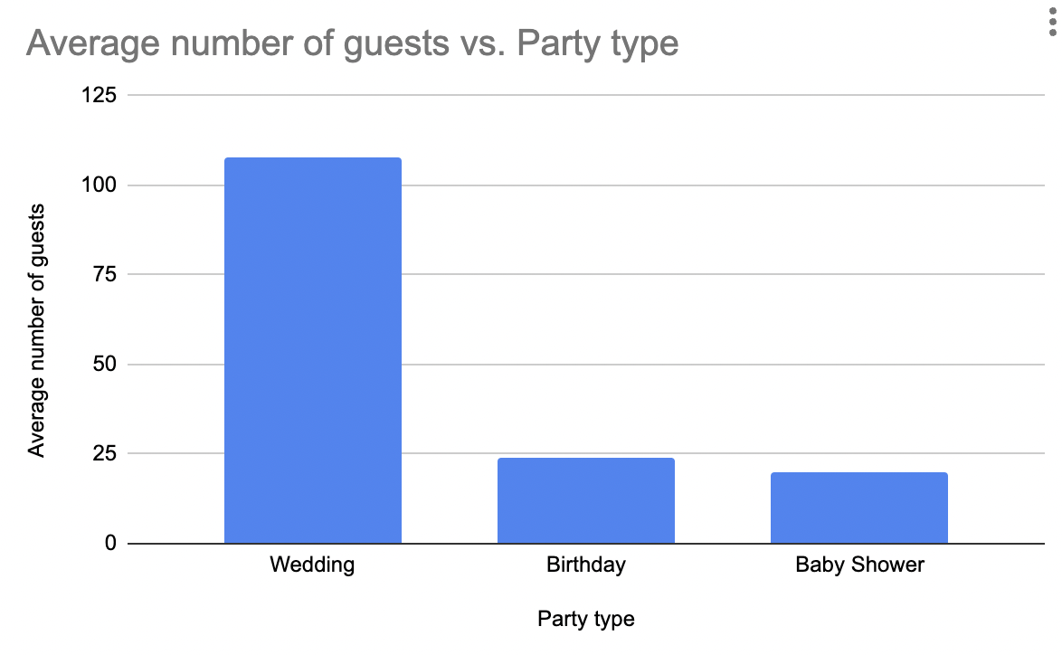

# Summary and Reflection

This project concerns the database used by a mobile app named BeMyGuest. The app helps people organize and better manage guest and gift lists for events. Managing guest lists can be complex and time-consuming. That is just one of the many tasks to handle when planning an event. The BeMyGuest app takes that weight off the user's shoulders. The user only needs to enter the guest names and select the gifts to receive once and send out the invitation links. Then, the guests will do the work of confirming their presence, adding companions they will take to the party, and buying gifts.

I've identified six use cases and defined the database fields needed in each. The app must support a user creating an account, creating a party event, creating guests, creating a registry and adding desired gifts. The app must also support guests buying gifts, and adding companions they will take to the party. Furthermore, the database must associate parties to an account, guests and gifts to a party, purchases and companions to guests.

From the use cases I derived 10 structural database rules and identified 10 entities of Account, Party, Wedding, Birthday, BabyShower, Guest, Registry, Gift, Purchase, and Store. The rules describe the constraints and relationships between the entities. To better understand and visualize these relationships, I drew a conceptual Entity-Relationship Diagram (ERD) using UML. The ERD shows the associative relationships between entities, and the hierarchy of Party/Wedding, Party/Birthday, and Party/BabyShower to show the different kinds of party a person can create on the BeMyGuest App.

To better understand the completeness and disjointness constraints, I drew an initial DBMS physical ERD. The physical ERD contains the same entities as the conceptual ERD, but it focuses on the relationship classifications to determine the placement of foreign keys.

In order to draw a full DBMS physical ERD, I added the attributes to each and every entity. Then, I noticed that the tables needed to be normalized to avoid data redundancy. After normalization, new entities emerged: Address, State, DressCode, Gender, and Theme. With the new entities and relationships added to the diagram, I drew a full DBMS physical ERD.

On previous iterations, I created the SQL script with the tables, sequences, stored procedures, queries and indexes. This week, I added the Gift_price_change history table, which is maintained by a trigger. I also added a couple of data visualizations to tell useful stories about the data.

# References

1. <https://www.ibm.com/docs/en/sva/10.0.0?topic=differences-length-names>
2. <https://kb.winzip.com/help/en/wz/help_password.htm>
3. <https://kytebaby.com/collections/bamboo-jersey-hooded-zippered-romper/products/bamboo-jersey-hooded-zippered-romper-in-fog>